**ClinionTM-Clinical Trial Solution v3.0**

**Paper Studies**

**Data Manager - User Manual**

**Version: 3.0**

**Effective Date: 28-JUN-2015**

Table of Contents

1.0 Purpose 3

2.0 Scope 3

**3.0 Dashboard………………………………………………………………………………………………………………………3**

3.0 Clinion™ Modules 3

4.0 User Workflows 4

4.1 Study Dashboard 4

4.2 Study Documents 6

4.3 Query List 8

4.4 Standard Reports 18

4.5 Data Extraction 21

4.6 User Profile Setup and Administration 25

4.7 Audit Log 26

4.8 Lock Study / Site 28

4.9 Create Sites 28

4.10 Medical Coding 30

4.11 Admin Tasks 34

5.0 Help Desk 35

# Purpose

This user manual provides an overview of Clinion™- Clinical Trial Solution, modules, and data management workflow, for paper studies. This manual provides guidelines for the Data Manager to use Clinion™- Clinical Trial Solution.

# Scope

The scope of this manual is limited to describing the system functionalities and related workflows for Data Manager, in paper studies.

# Clinion™ Modules

The following modules are available to Data Manager:

* Study Dashboard
* Comparison Reconciliation and Batch Edit Checks
* Data Capture (Subject Enrollment)
* Query Resolution System
* Data Loader
* Standard Reports
* Data Extraction
* Profile Setup
* Audit Log
* Create Sites
* Lock Study or Sites
* Medical Coding
* Admin Tasks
* Help Desk

# 

# User Workflows

## 4.1 Study Dashboard

* The Data Manager logs in to the application, with the login credentials created by the Study Admin. The data manager receives the login credentials on the email address provided by the Study Admin, while creating the account.

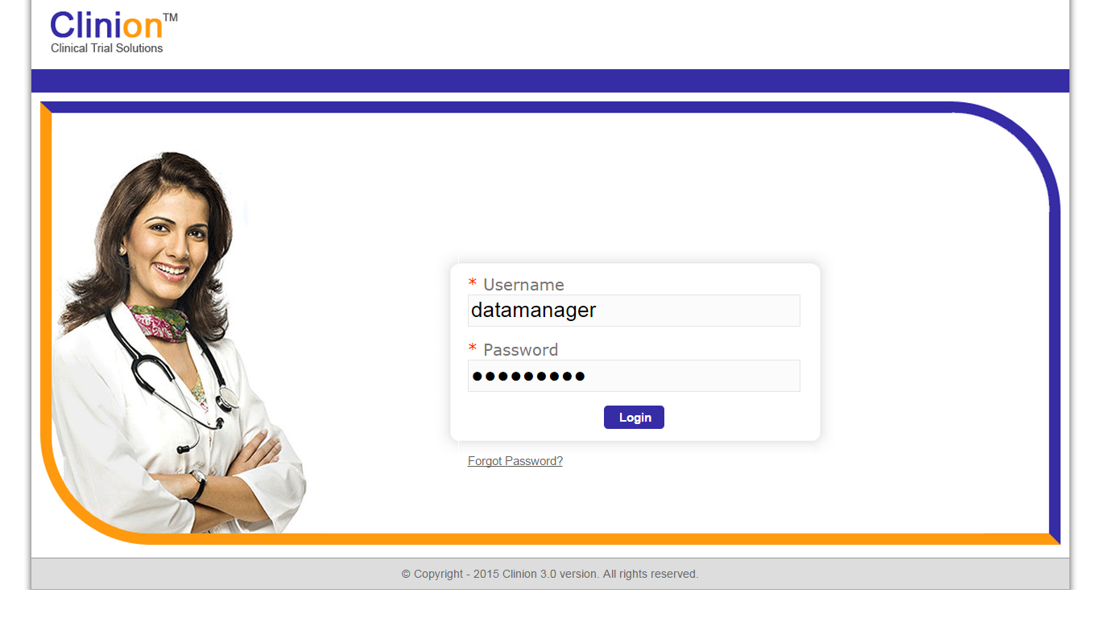

4.1.1: Data Manager’s Login Page

* After logging in, the data manager is directed to the Dashboard which displays graphical information of all the sites. The information is represented in tables and graphs.

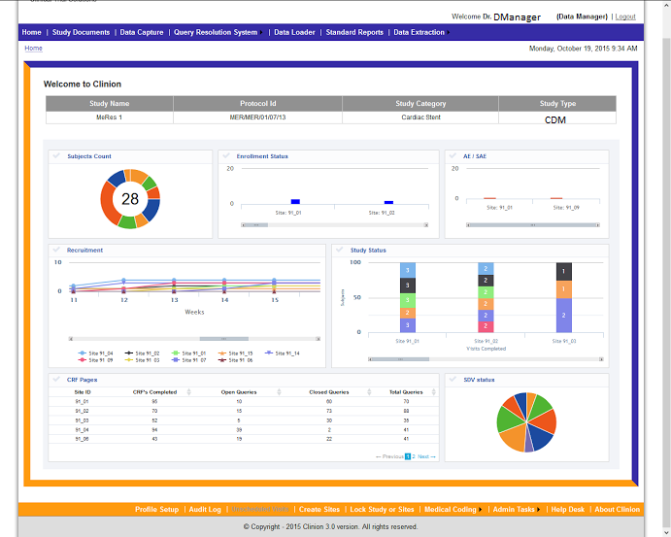

4.1.2: Data Manager – Dashboard

* The Data Manager’s Dashboard provides graphical information, on the following data points:

1. **Enrollment Status**: The Enrollment Status Graph represents the study completion status for all the sites. The system follows a color code to represent each of these statuses. The study completion statuses are represented in the following colors:
2. Orange color – N**ot yet started.**
3. Blue color – I**n progress**.
4. Red color – **Excluded** from the study.
5. Green color – **Completed** the study.
6. Black/Grey color – **Withdrawn** from the study.

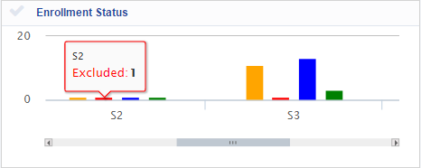

4.1.3: Data Manager – Dashboard (Enrollment Status)

With mouse over on individual bar graphs for a given site, the total count of subjects along with the individual Site ID’s is displayed. If there are multiple sites, the scroll bar, at the bottom can be used to scroll towards the right and see the enrollment status of other sites.

1. **Subject Count:**

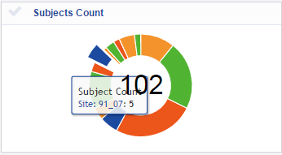

4.1.4: Data Manager – Dashboard (Subjects Count)

This ring chart gives the count of subjects in each status of the study (In progress, not started, withdrawn, excluded and completed), for all the sites. The mouse over displays the Subject Count, Site ID, followed by the number of subjects. In the center of this chart, the data manager can see the cumulative count of the subjects who are in progress and those who have completed the studies.

1. **AE/SAE:**

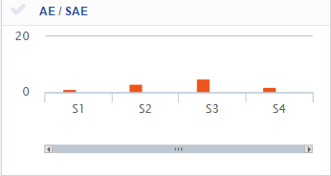

4.1.5: Data Manager – Dashboard (AE/SAE)

This graph gives the total number of Adverse Events and Serious Adverse Events recorded, per site. The data manager can scroll towards the right to see the number of AE’s and SAE’s, recorded in other sites. With mouse over, the data manager can see the count of AE/SAE recorded, per site.

1. **Recruitment:**

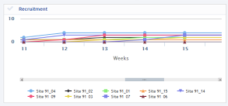

4.1.6: Data Manager – Dashboard (AE/SAE)

In this graph, the data manager can see the number of subjects enrolled per site, in a week wise pattern. The mouse over, over any point in the graph gives the cumulative count of subjects enrolled in the site, until that point. At the bottom of the graph, the data manager can see the Site numbers represented in different colors. To see the recruitment status of one site, click on the Site number of that particular site.

1. **Study Status:**

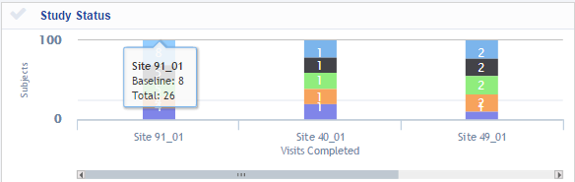

4.1.7: Data Manager – Dashboard (Study Status)

The Study Status graph gives Subjects vs. Visits Completed information. It represents the total number of subjects that have completed visits per site. Each bar graph is divided into sections that depict the visits in the study and each visit is displayed in a different color. With mouse over, the data manager can see the Site Name, Visit name with the number of subjects that have completed that visit, followed by the total number of subjects in the site. The scroll bar can be used to see the study status of other sites, if any.

1. **CRF Pages:**

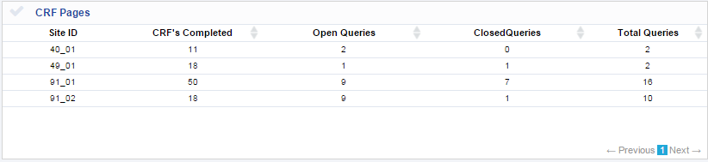

4.1.8: Data Manager – Dashboard (CRF Pages)

The CRF pages table gives information on the CRF pages completed per site. The total number of Queries, including Open and Closed Queries, can be seen in the table. The pagination at the bottom can be used to view the CRF page information of more sites, if any.

1. **SDV Status:**

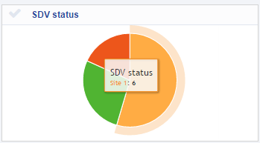

4.1.9: Data Manager – Dashboard (SDV Status)

The SDV status of all the sites is presented in the SDV status pie chart. Each site is presented in a different color. With mouse over, the Site name and the number of subjects for which the SDV has been done, can be seen.

## 4.2 Study Documents

**Features:**

* Multiple study documents can be uploaded quickly and accessed over the web.
* Easy Retrieval/Download of Study related Documents.

**Workflow:**

* In the home page, click on study documents in the header menu.

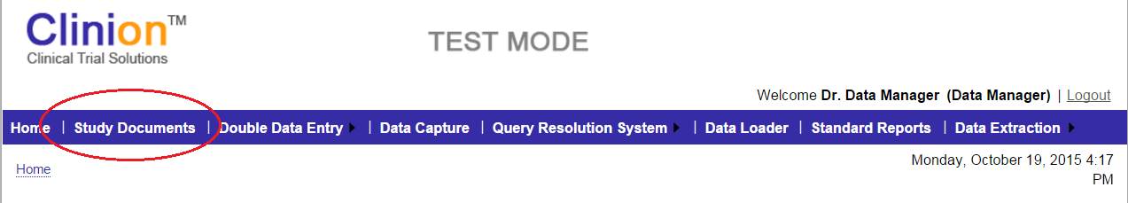

4.2.1: Data Manager – Study Documents (Header)

* The Study Documents page has ‘Add Document’ section, where documents can be uploaded and information on the uploaded documents can be seen in the table, at the bottom of the page.
* If no document is uploaded, ‘No file Chosen’ message can be seen next to ‘Choose File.’
* To Upload a document, click on ‘Choose File’, browse and upload the desired document.
* Enter the ‘Title’ of the document in the Title field.
* Select the ‘Version’ of the document. If it’s a primary document, select the Version as Major and if the document is a part of the primary document, upload it as a Minor version.
* Click on Submit after uploading the document. Once the document is uploaded, a message would appear above the Select Document field, ‘Document added successfully.’

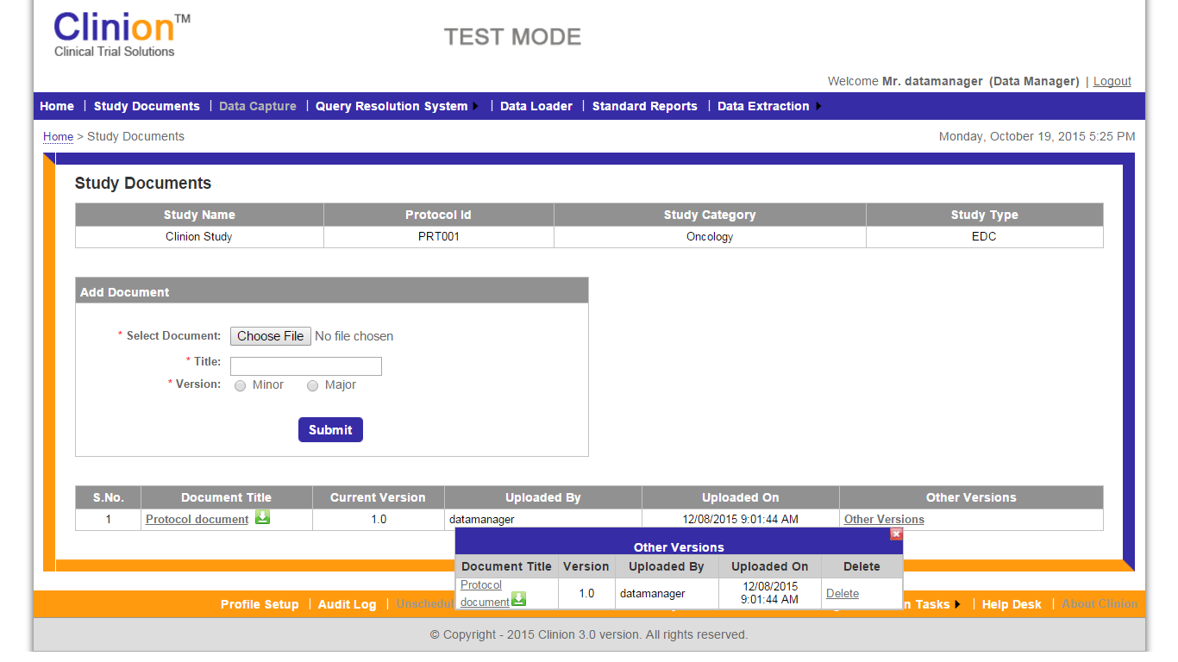

4.2.2: Data Manager – Study Documents

* Details of the attached document can be seen in the table below the Add Document section. The table has the following information:

1. S.No.
2. Document Title
3. Current Version
4. Uploaded By (username)
5. Uploaded On (Date and Time)

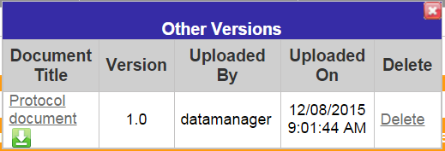

4.2.3: Data Manager – Study Documents (Other Versions)

* Other Versions (link): Click on ‘Other Versions’ to see the details of the uploaded document, in Other Versions window. The Other Version’s box has Document Title, Version, Uploaded by, Uploaded on (Date and time) and Delete Option.
* Click on Delete, in order to delete the uploaded document. A validation appears on the screen before deleting the document, ‘Are you sure you want to delete the version …?.’ Click on ‘OK’ to delete the document and click on ‘Cancel’ to go back to the Study documents page.

## 4.3 Comparison reconciliation & batch edit checks

**Features:**

* Reconciliation of the data entered by First and Second pass Data Entry Operators and committing it to the database.
* Running Batch Edit checks for the committed data of the subjects.

**Workflow: DDE, Comparison Reconciliation and Batch Edit Checks:**

* Data Manager Enrolls the subjects into the study, post which the paper/hard copies of CRF are sent to the site.
* Data is captured in the hardcopies of the eCRF, by the site personnel and is sent to the Data Management team.
* The Data Management team performs the Double Data Entry (First pass entry followed by the second pass data entry), in the eCRF pages.
* Data Manager reconciles the data entered by both the operators. Choosing one value, if different data is entered by the DDE operators for a given item and committing it to the database is at the Data Manager’s discretion.
* Data Manager runs the batch edit checks after committing the data to the database.
* Individual queries are printed from the Query List and are sent to the site for Resolution via post.
* Status of the queries is updated by the Data Manager on receiving a response from the site.

**COMPARISON RECONCILIATION**

* Click on Comparison Reconciliation from the Double Data Entry dropdown in the header of the page.

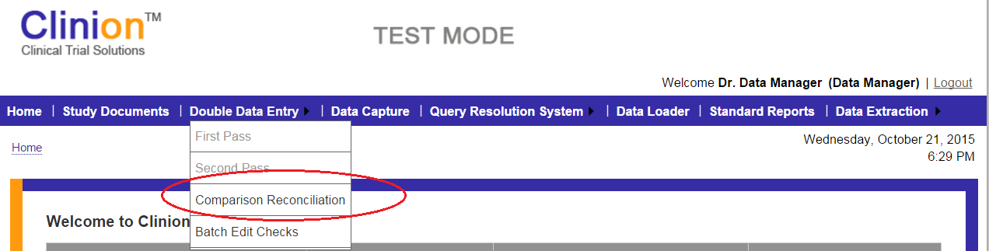

4.3.1: Data Manager – Comparison Reconciliation

* Comparison Reconciliation page opens. Select the Site and subject for data verification, from the drop downs provided for ‘Site’ and ‘Subject.

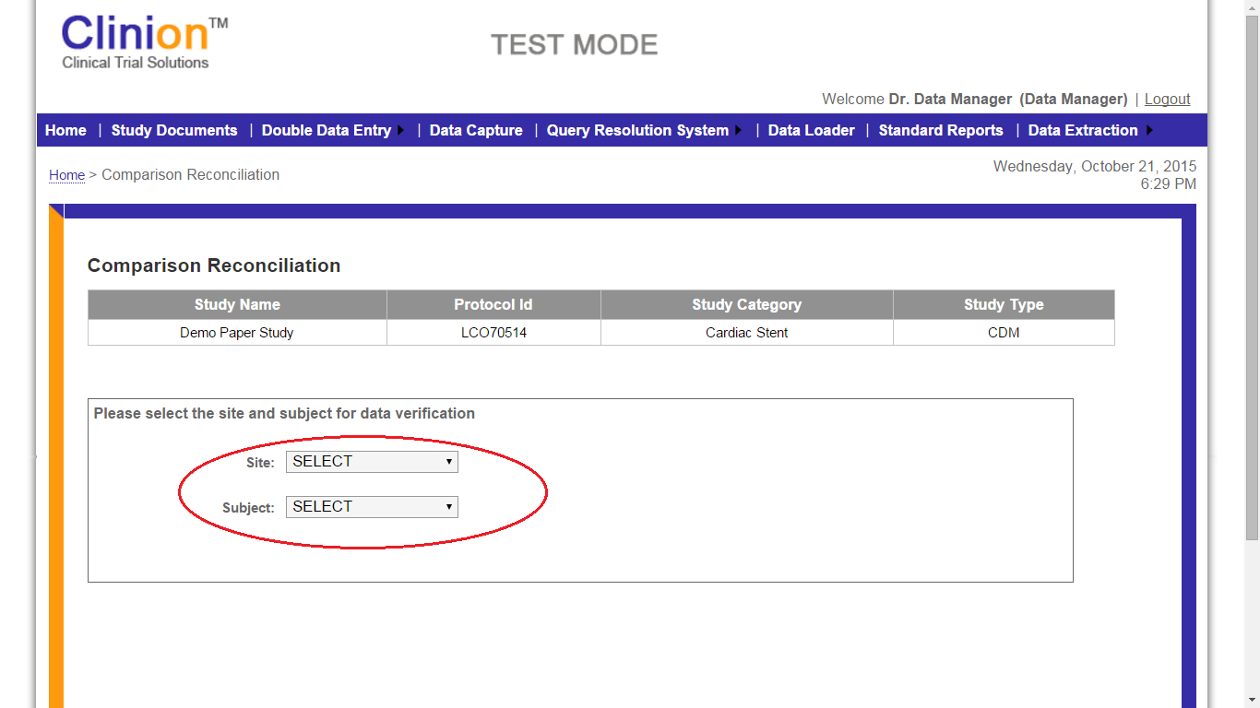

4.3.2: Data Manager – Comparison Reconciliation (Select Site & Subject)

* Comparison Reconciliation page opens. Select the Site and subject for data verification, from the drop downs provided for ‘Site’ and ‘Subject, respectively.
* On selecting the Site and subject, ‘Compare and Reconcile’ button appears on the screen, below the drop downs.
* Click on the ‘Compare and Reconcile’ button to see the Reconciliation report of the selected subject.

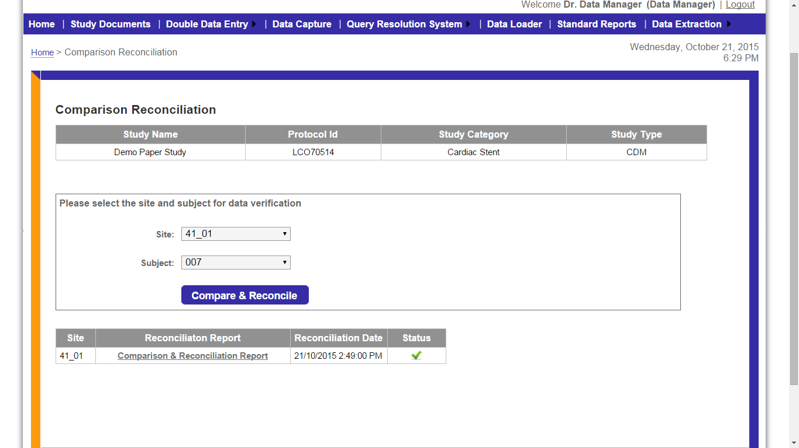

4.3.3: Data Manager – Comparison Reconciliation (Reconciliation Report)

* Reconciliation details of the subject are displayed in a table which provides the Site ID, Reconciliation Report (link), Reconciliation Date and the Status.
* If the DDE (both first and second pass entry) is not performed for a given subject, the status appears as an Exclamation mark (in yellow). Mouse over on this icon shows, ‘Pending Selection.’
* If the DDE has been performed for a subject and the selected values are saved and committed to the DB, the status is displayed in a green colored tick mark, as seen in the screenshot.
* If there is no data available to compare and reconcile for a subject, the status appears in a red colored cross mark.
* If the status is ‘Pending selection’, Click on the Comparison & Reconciliation Report link.
* Comparison Reconciliation Report page opens.

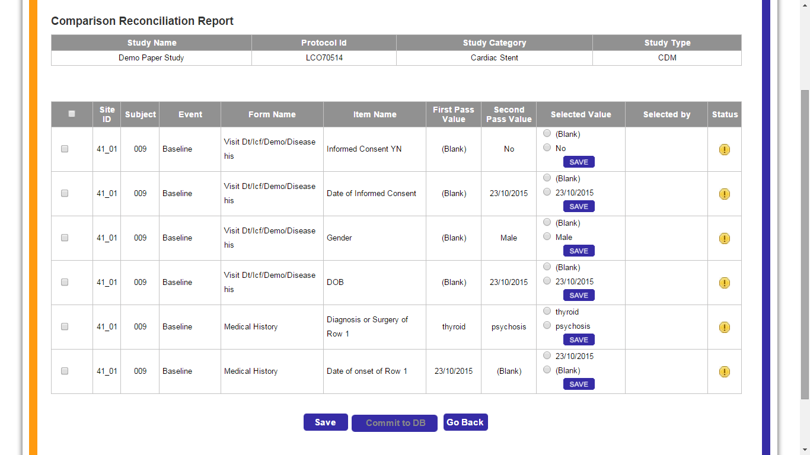

4.3.4: Data Manager – Comparison Reconciliation Report Page

* Comparison Reconciliation Report page displays the first and second pass data entry values, entered for individual items. These DDE values appear on this page, only if the entered values are different from one another.
* The table contains the following columns:

1. Site ID
2. Subject ID
3. Event (Visit Name)
4. Form Name (Page name)
5. Item Name
6. First Pass Value
7. Second Pass Value
8. Selected Value (Radio buttons for both the values)
9. Selected by (username)
10. Status (Information icon appears in this field, if no value has been selected (mouse over, shows ‘Pending selection’; it displays a database icon if the value has been selected but has not been committed to the database).

* Below the table, ‘Save’, ‘Commit to DB’ and ‘Go Back’ buttons are available. The ‘Commit to DB’ button appears disabled unless all the values are selected and saved.
* Click on save (In the Selected Value column), after selecting a value for any given item.
* As soon as a value is selected and saved, the ‘Selected by’ column reflects the username of the user who saved the value.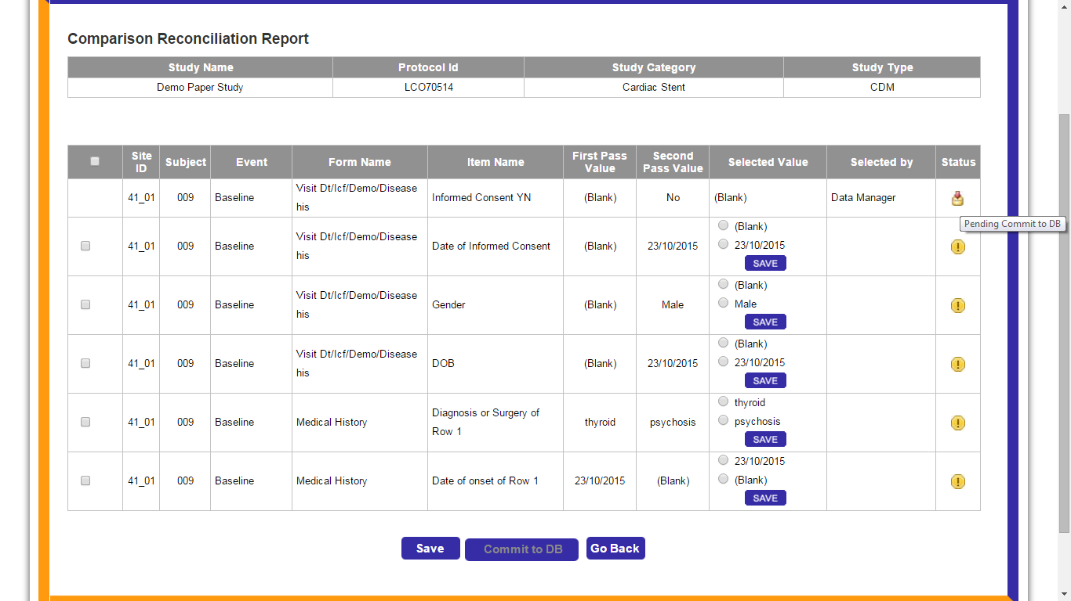

4.3.5: Data Manager – Comparison Reconciliation Report (Pending Commit to DB)

* The status column reflects the ‘Pending Commit to DB’ icon, after the value is selected and saved.

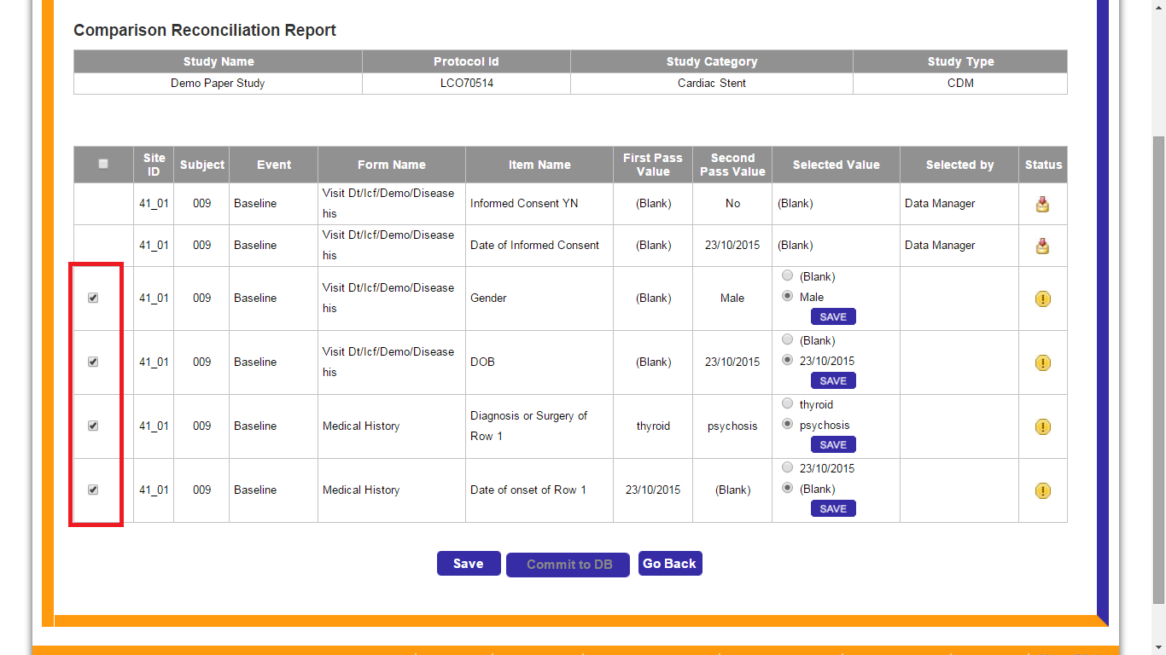

4.3.6: Data Manager – Comparison Reconciliation Report (Save)

* The first and second pass values can be selected individually or collectively, by checking the checkboxes in the extreme left of the table.
* After selecting the checkboxes, click on the ‘Save’ button.
* The status of all the selected items reflect the ‘Pending Commit to DB’ icon, after the values are saved and the ‘Commit to DB’ button, at the bottom of the page appears enabled.

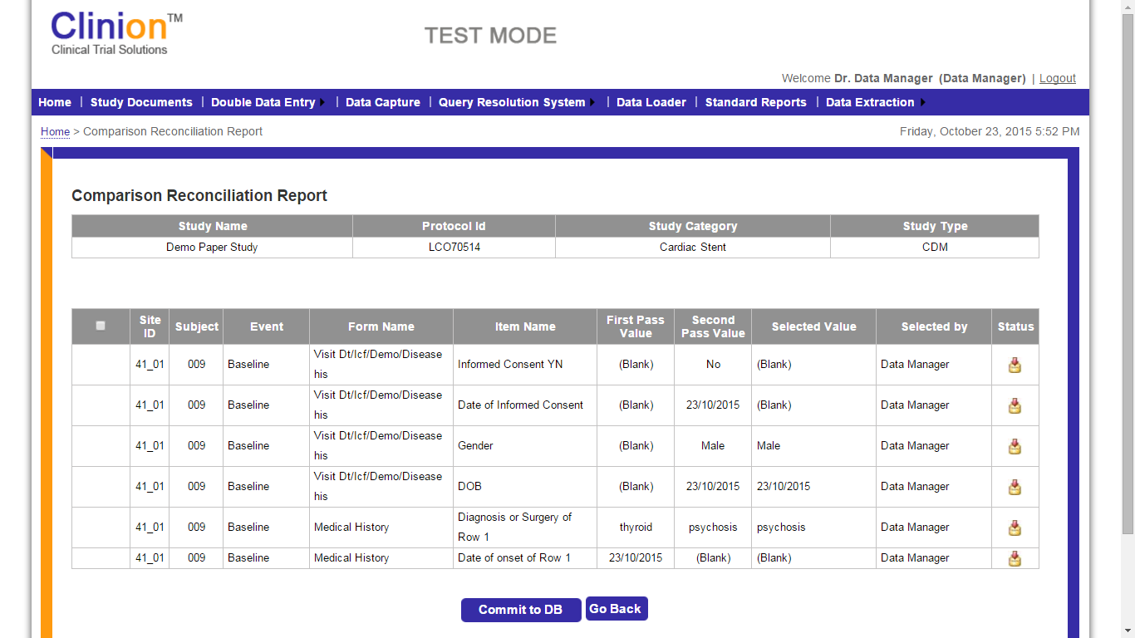

4.3.7: Data Manager – Comparison Reconciliation Report (Commit to DB)

* Click on ‘Go Back’ to navigate back to the Comparison Reconciliation page.
* Click on ‘Commit to DB’ to commit the selected and saved values to the database for the subject.
* Once the values are saved and committed to the database, the Comparison Reconciliation page is displayed.
* The status of the Reconciliation report appears in a green tick mark. Mouse over on this status, shows ‘Committed to DB’ message.

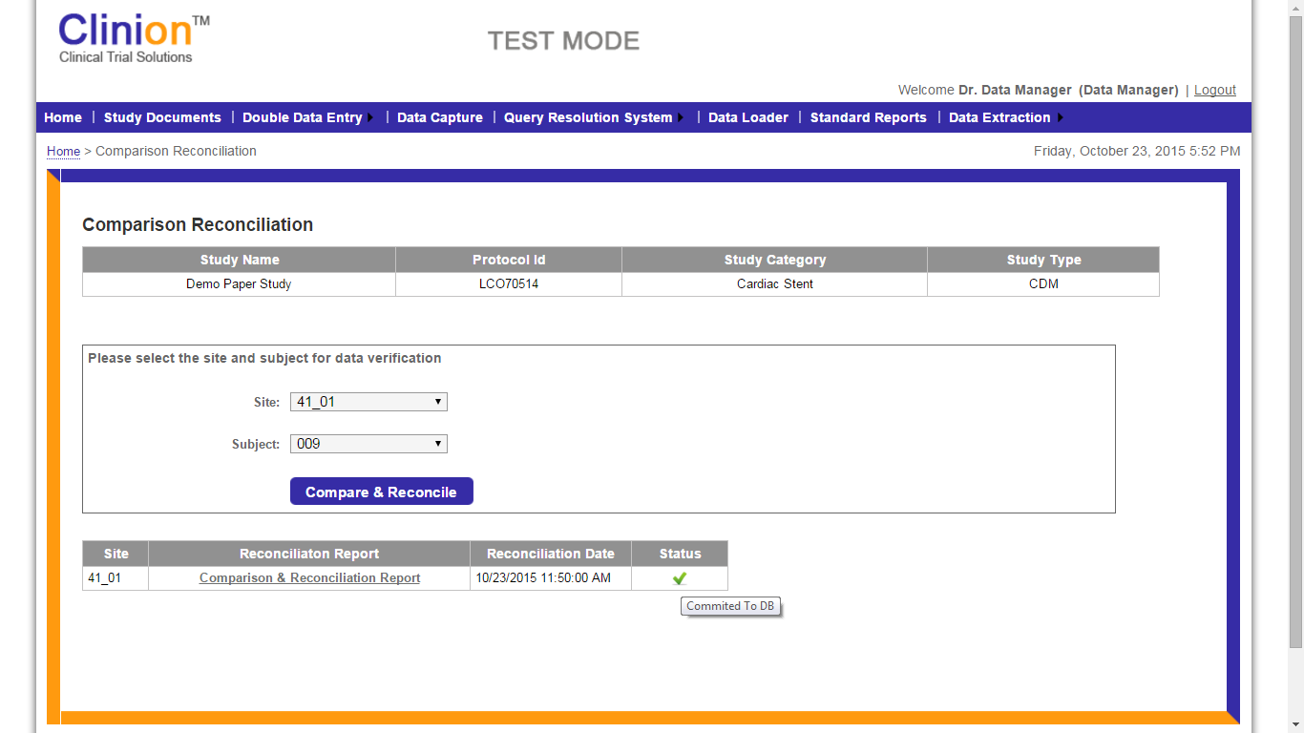

4.3.8: Data Manager – Comparison Reconciliation Report (Committed to DB)

**BATCH EDIT CHECKS**

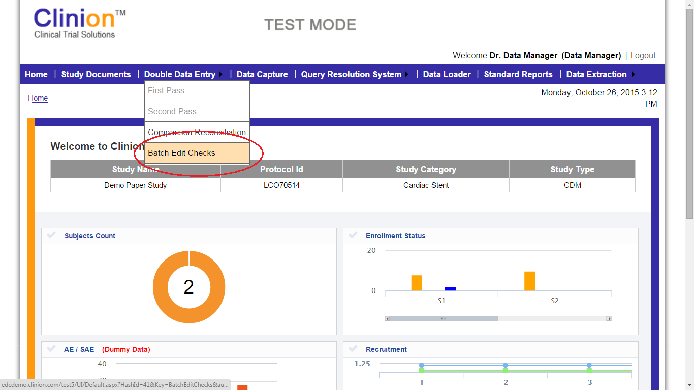

4.3.9: Data Manager – Batch Edit Checks

**Features:**

* Robust Query management system where Automated Queries are generated for data values out of range or those that have failed to meet the predefined edit check configured for a Data item.
* Manual queries can be raised by Data Manager and assigned to the Site level personnel.
* The Data Manager can view the list of queries generated in the query list provided under the Query List tab.
* The Data Manager can raise a Manual query which would direct to the page where queries can be raised.

**Workflow:**

* The Data manager clicks on the “Query List” under the “Query List” menu item in the header to navigate to the Query List page.
* The Query List page contains the following sections:
  1. Filter (Site ID, Subject ID, Visit Name, Status of Query, All Queries (irrespective of the site))
  2. Query List
  3. Query List Activities
* The Data manager can use filter options available in the first section to refine the queries as per the below criteria.
  1. Site Id
  2. Subject Id
  3. Visit Name
  4. Status
  5. All Queries / Queries assigned to me.

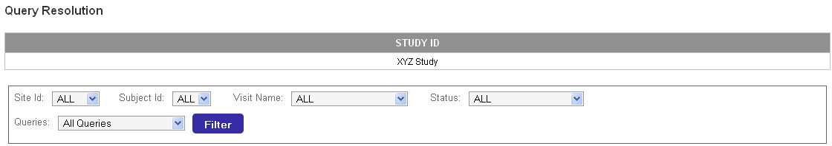

Figure.4: Query List

* The Query list section contains list of queries with the following attributes
  1. Site Id
  2. Batch Id
  3. Subject Id
  4. Visit
  5. Page
  6. Item Name
  7. Query Title
  8. Status
  9. Assigned To
  10. Raised By
  11. Query Manager
  12. Posted On
  13. QRS Id
  14. Source Data Link
* The following color codes are displayed for the queries in the query list based on their statuses.
  1. New – Red
  2. Resolution Proposed – Orange
  3. Updated – Grey
  4. Closed – Green
* The Data Manager can click on the query title to open the individual query and can view the query in-detail.

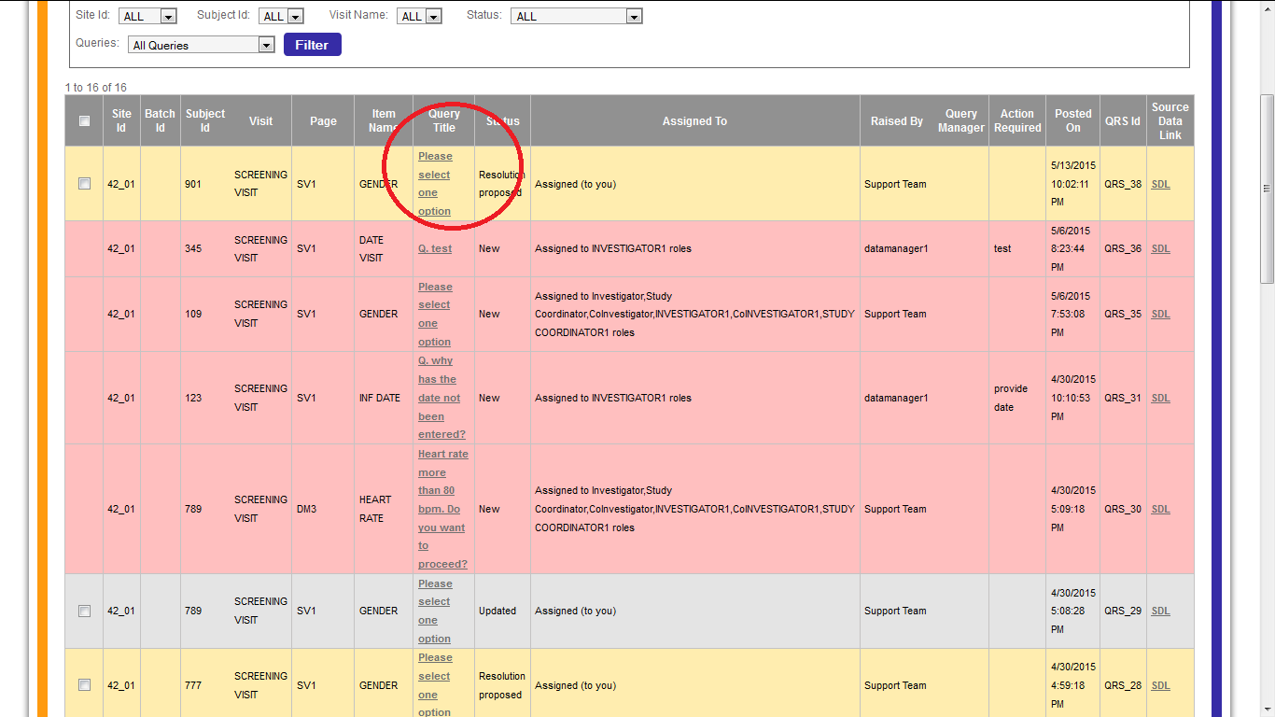

Figure 4.1: Query List Page (Query Title)

* To navigate to the eCRF where the query got raised, the Data Manager can click on SDL (Source data link) link available next to each query.

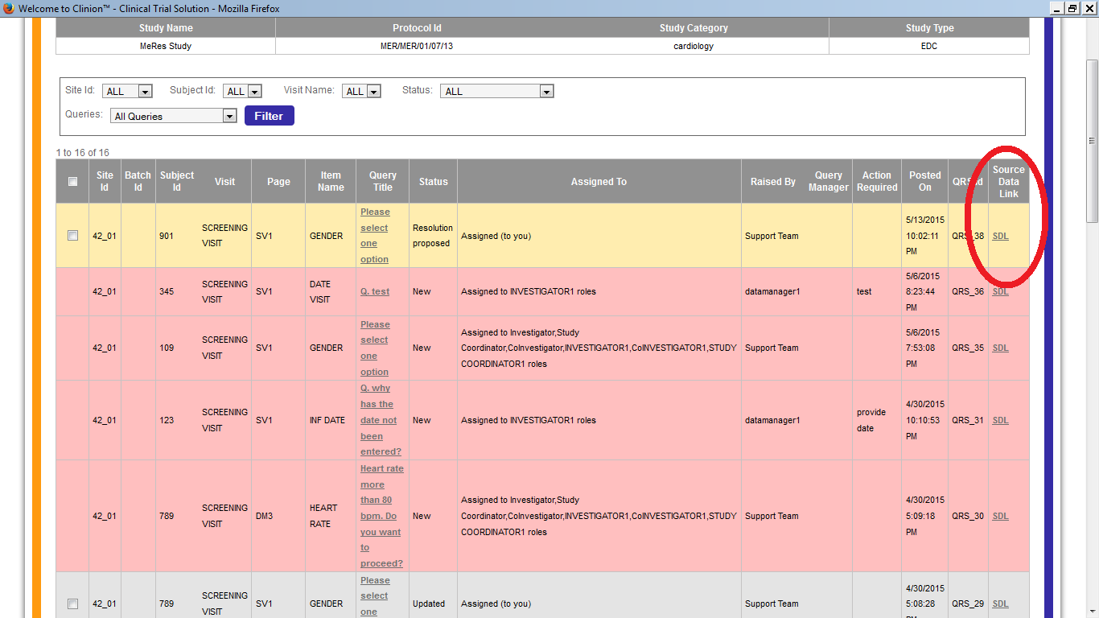

Figure 4.2: Query List Page (Source data link)

* **QUERY TITLE LINK**: On selecting this link, a page with the query details would appear on the screen. The data manager would have the option to reply (if it is resolution proposed) or Assign it to the Site level personnel, if it’s a new query.

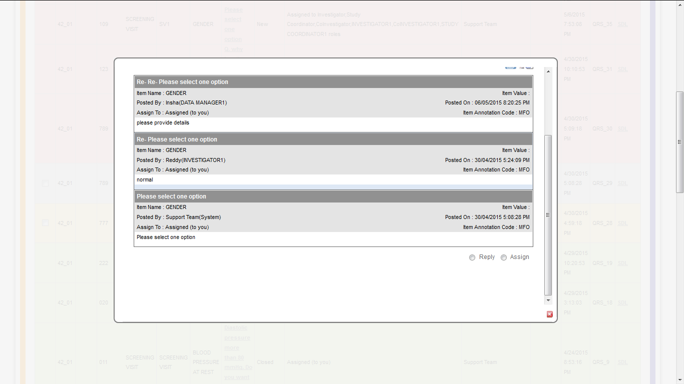

Figure 4.3: Query List Page (Query)

* **Reply:** On selecting the Reply option, the data manager would have to enter the Description in the text area, which is mandatory. After the description has been entered, the Data Manager can either Update the Query or Close it.

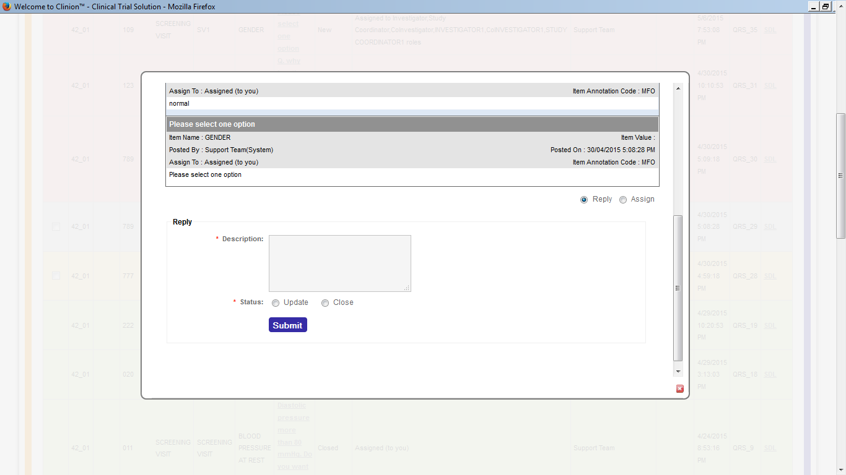

Figure 4.4: Query List (Reply to Query)

* **Assign:** On selecting the Assign option, the data manager would have to enter the description in the text area provided and select Trial or Site level so that the query is assigned to any of the roles that were assigned in the DCF workflow.

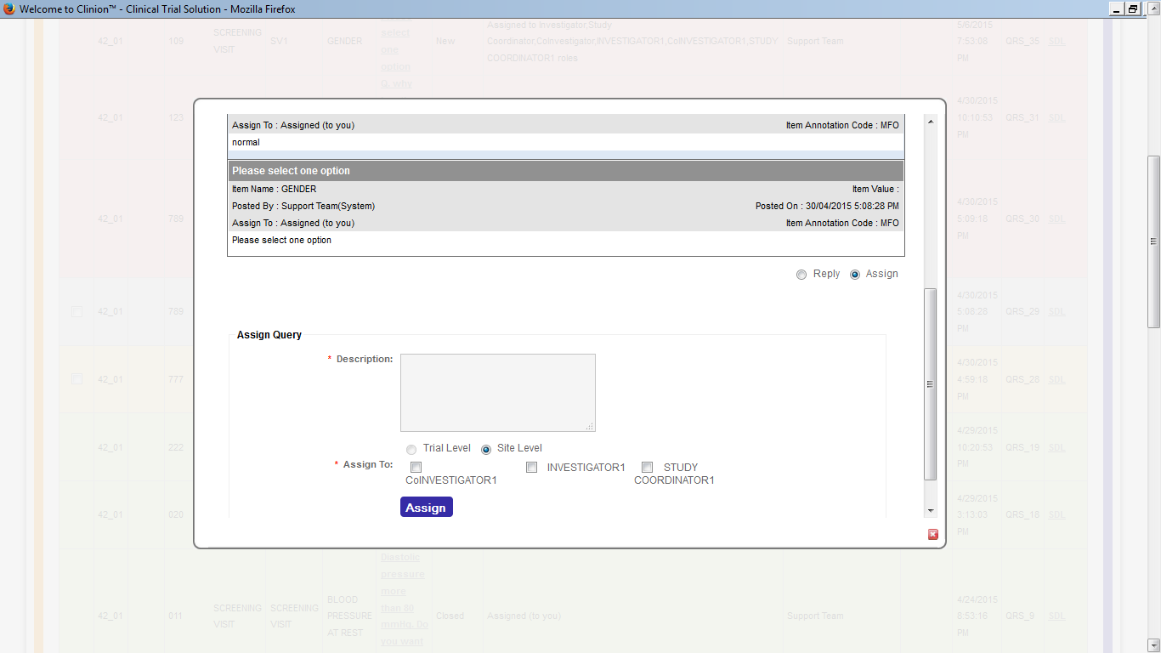

Figure 4.5: Query List (Assign the Query)

* **SOURCE DATA LINK**: If the Data Manager clicks on SDL, they would be directed to the eCRF page where auto query was generated. The field for which the query was raised, would appear red in color and in the same data field, a yellow colored query icon would be seen. On selecting the yellow icon, a page would appear wherein the data manager would be able to see the details of the query, which are the same as those seen in case of Query title link. The page also has options to Reply and Assign the query. This page would also provide the data manager with the option to raise a manual query, which has the following fields:

1. Subject, CRF, Pl Name, Item Name, Item Value (towards the left)
2. Event, Protocol ID, Item Annotation Code (towards the right)
3. Title (mandatory) with text area
4. Description (mandatory) with text area
5. Action Required (mandatory) with text area
6. Trial Level icon and Site level icon, which would enable the datamanager to assign it to a particular role/s in the selected level.
7. Once the Datamanager clicks on submit, the query icon in that data field turns red in color, from yellow. The data manager can raise multiple queries for the same data field on selecting the same query icon.

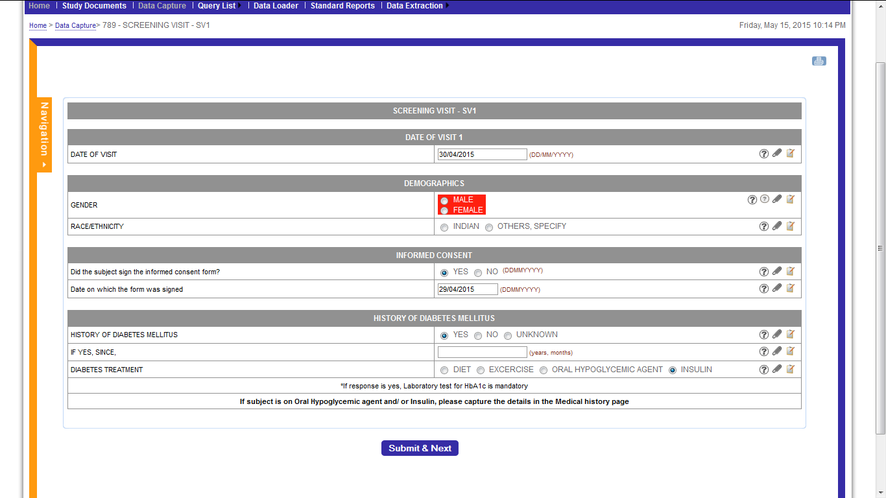

Figure 4.6: Query List (Query icon-yellow in color)

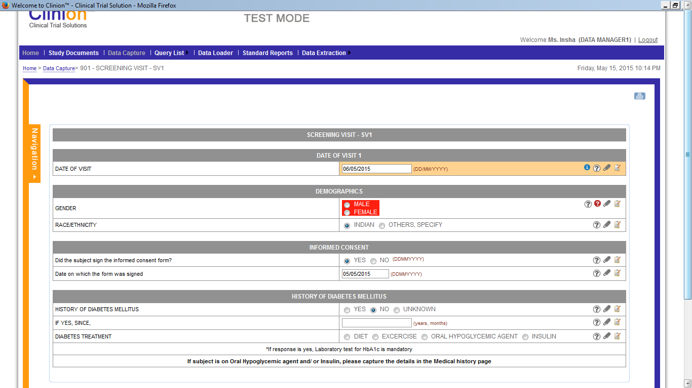

Figure 4.6: SDL (e-CRF page)

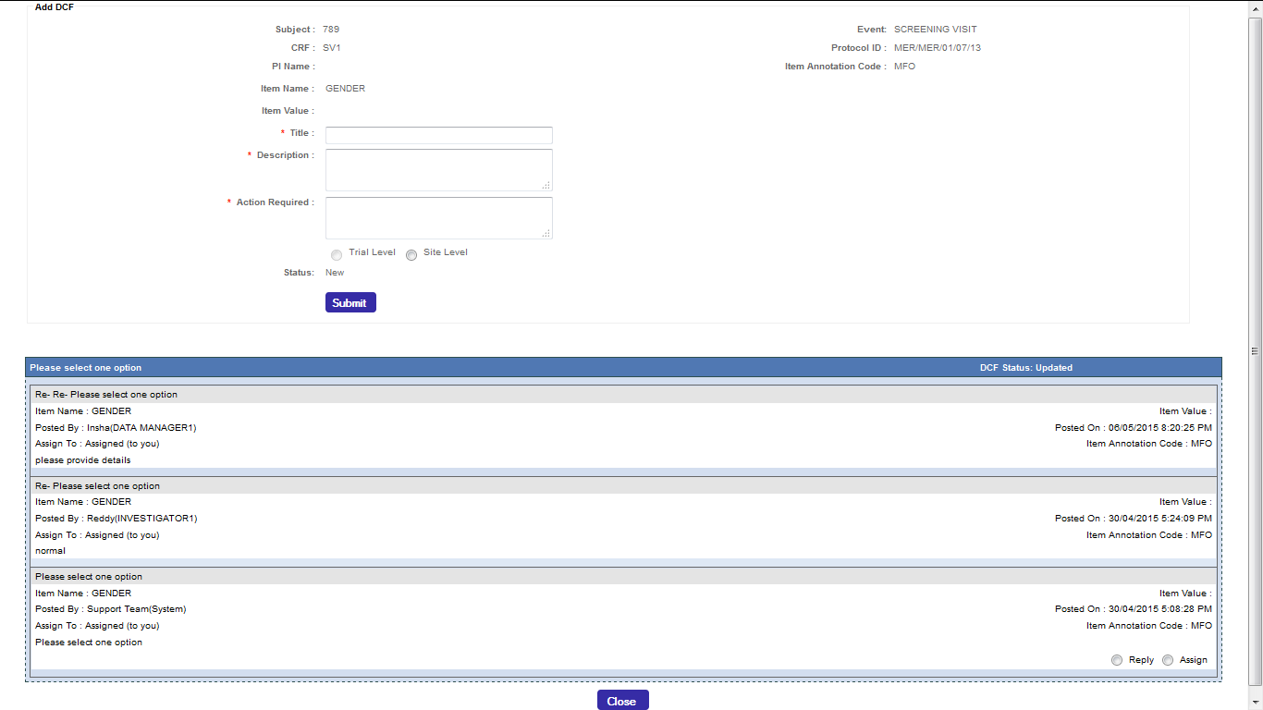

Figure 4.7: Query Page

* Each of these eCRF pages which the data manager is directed to, on selecting SDL, is provided with the Print Icon towards the top right corner of the page.
* Next to each data field, there are Add notes and Add files Icons.
* The data manager can upload multiple files (maximum size of each file, 10 MB), for each data field.

### 4.3.1 Raising Manual Queries

**Features:**

* Data Manager can raise Ad-hoc Queries for any data item in a particular eCRF of the subject.
* Data Manager can assign the query to any concerned study role by filling up the Data Clarification Form (DCF)

**Workflow:**

* In order to raise a Manual Query, the Data Manager clicks on Raise Query menu item from Query List menu in the header.

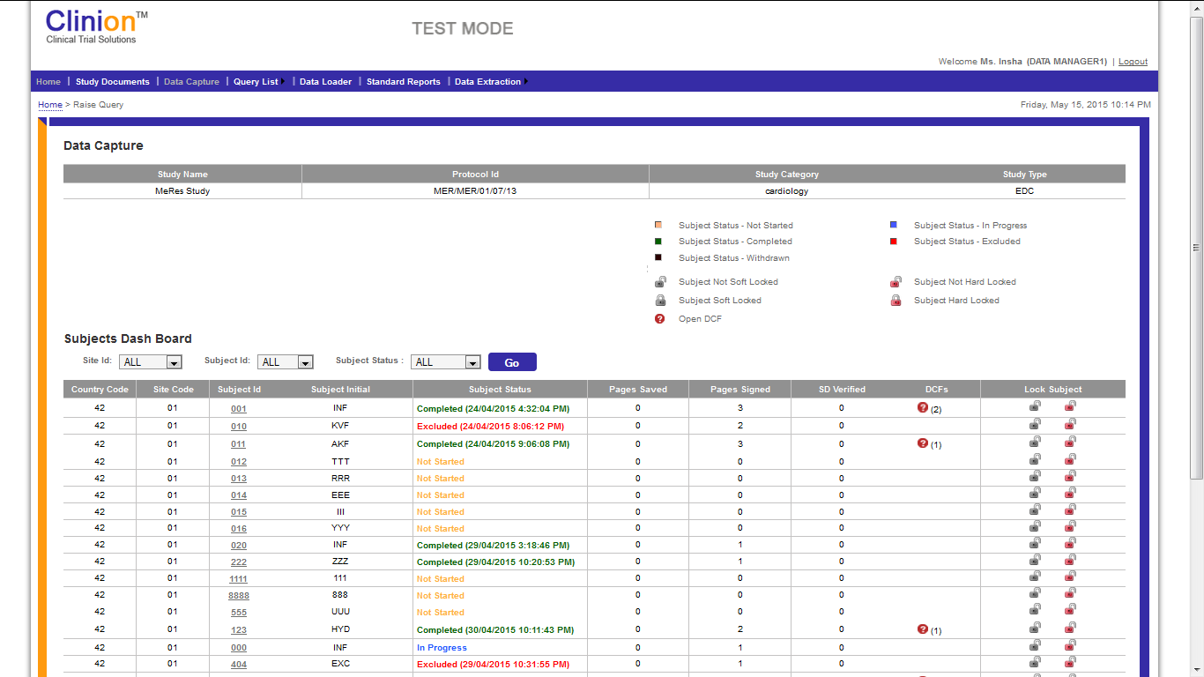

Figure. 5.0: Raise Query – Subjects Dashboard

Subjects Dashboard is displayed to the Data Manager with the list of subjects in different sites.

* By clicking on the subject, a Pop-up is displayed with all the available visits.

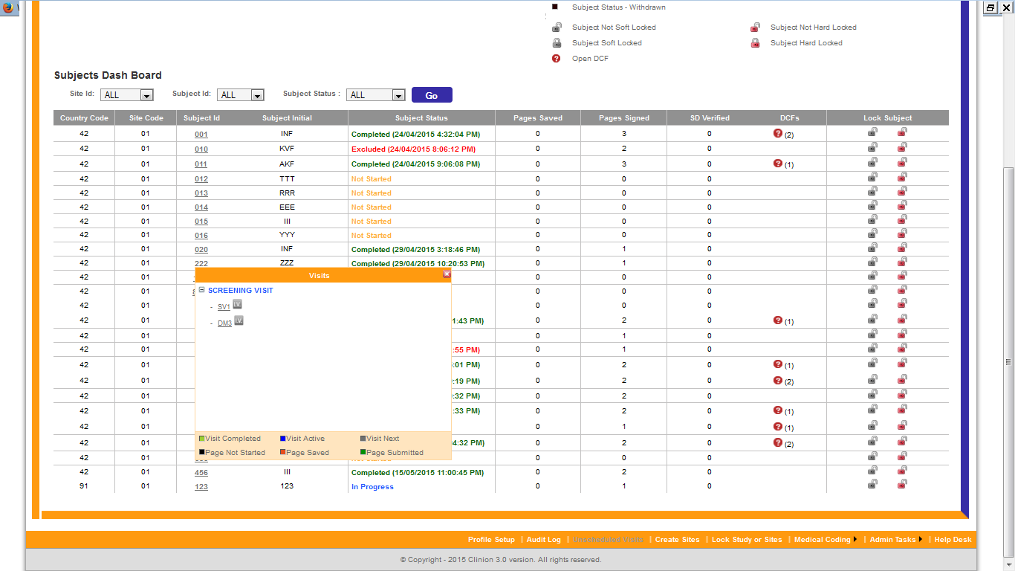

Figure 5.1: Raise Query - Visits

* When the Data Manager clicks on the Visit name, all the eCRFs available in the visit are displayed.
* Legends are displayed for all the different statuses of Visits and Pages in the bottom of the Visits popup.
* The query icon beside the page name resembles that the eCRF page contains open queries whereas the ‘IV’ icon denotes that the respective page is investigator verified.
* By clicking on any of the eCRF pages, the Data Manager is navigated to the respective eCRF page.
* Data Manager can raise Ad-hoc Query against any Data Item in CRF by clicking the white question mark icon displayed next to each data item.

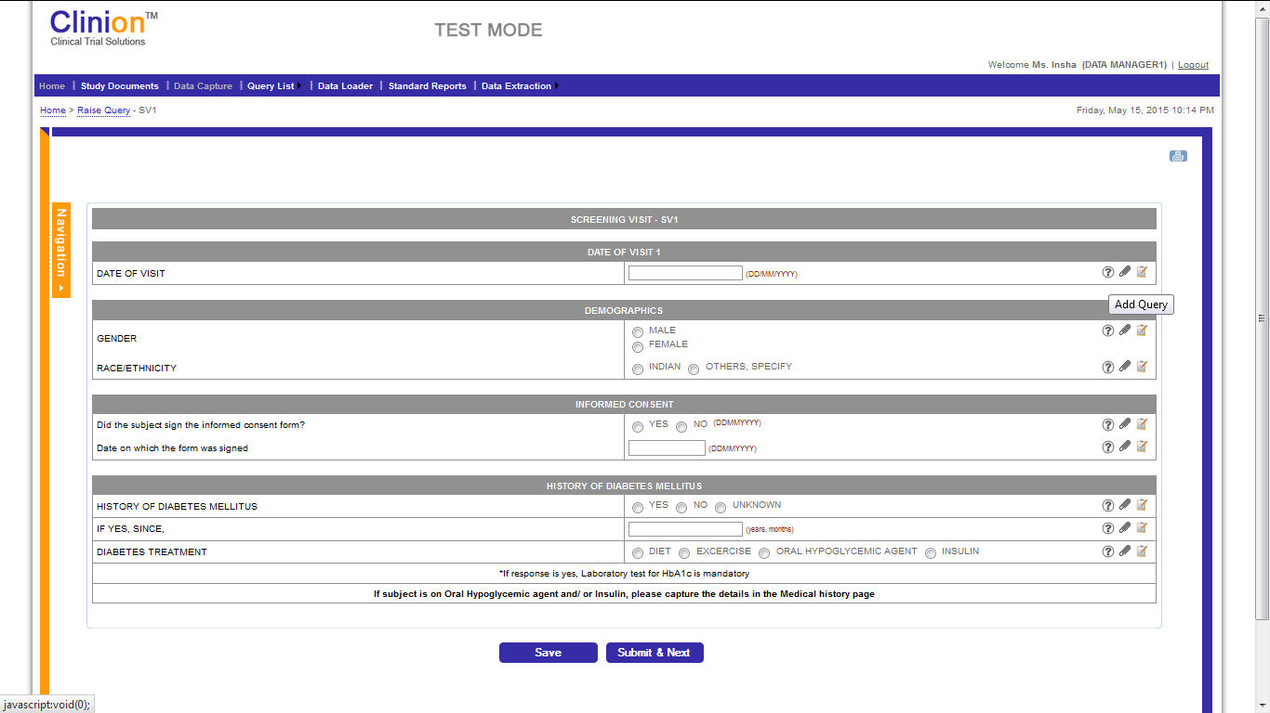

Figure 5.2: Raise Query – Question Mark Icon

* A Data Clarification Form is displayed, where Data Manager can provide Title, Description, Action required and assigns the query to concerned study role along with Priority.

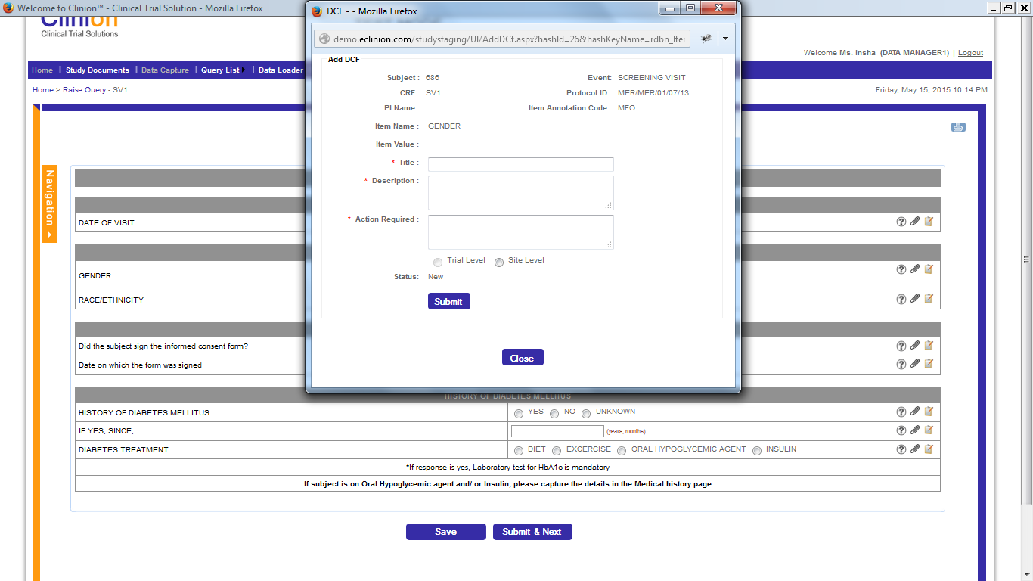

Figure 5.3: Raise Query – Data Clarification Form

* The Data Manager can assign the query to a particular study role as per the defined query workflow.
* After submitting the form, the query is raised in the eCRF page. A red query icon is displayed in the eCRF page and a query is added to the query list.

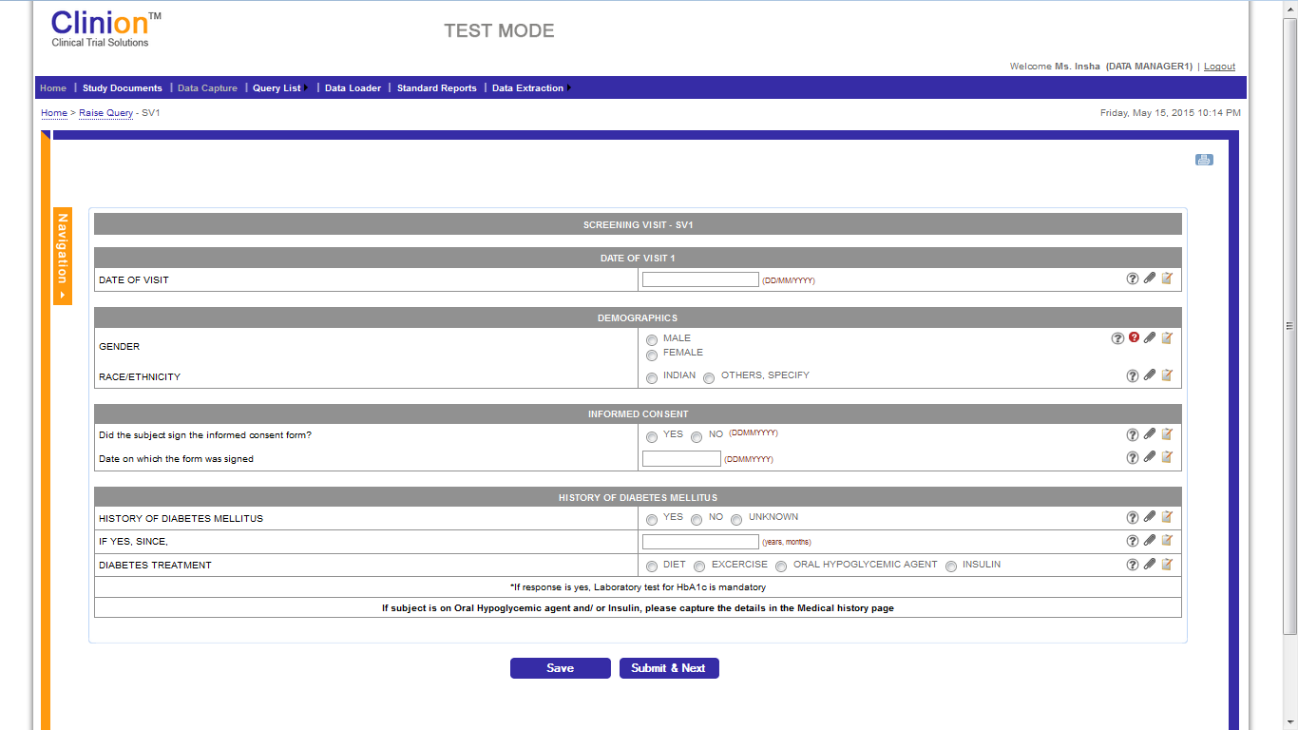

Figure 5.4: Raise Query – Query Icon turns Red in color

### 

## 4.4 Standard Reports

**Features:**

* The system offers 4 Standard Reports that are available to the Data Manager.
* Query Ageing Report
* Query Count by Subject
* Site Summary Report
* SDV Status Report
* The Data Manager can print the reports by clicking on the Print icon available on the page.
* The reports can be extracted to excel and PDF formats by clicking on the respective icons displayed on the page.
* The Data Manager can filter the sites or view the reports of all the sites, by using the filter option.
* **Query Ageing Report** has the following details:

1. Site ID
2. Subject
3. Visit Name
4. Query Description
5. Query date
6. Query Updated Date
7. Ageing Period (Days): If the queries exceed the days limit which was configured in the query workflow, they appear Red in color.

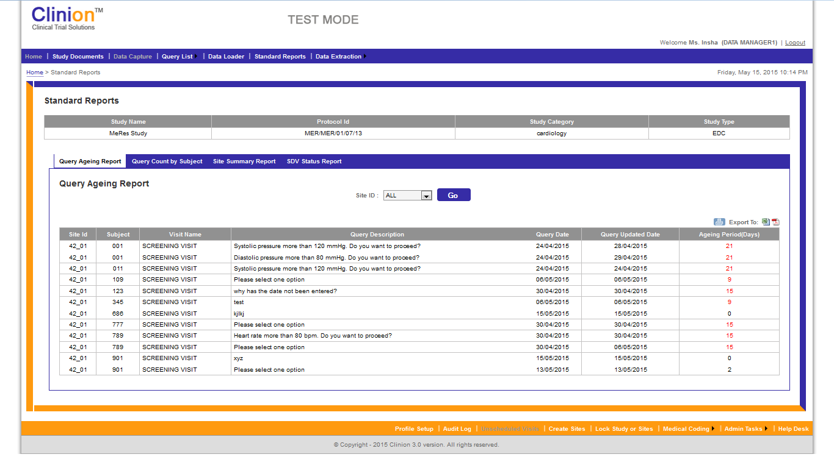

Figure.6.0: Standard Reports – Query Ageing report

* **Query Count by Subject** has the following details:

1. Site ID
2. Subject
3. Visit Name
4. Page Name
5. No. of Open Discrepancies
6. No. of Closed Discrepancies
7. Total No. of Discrepancies

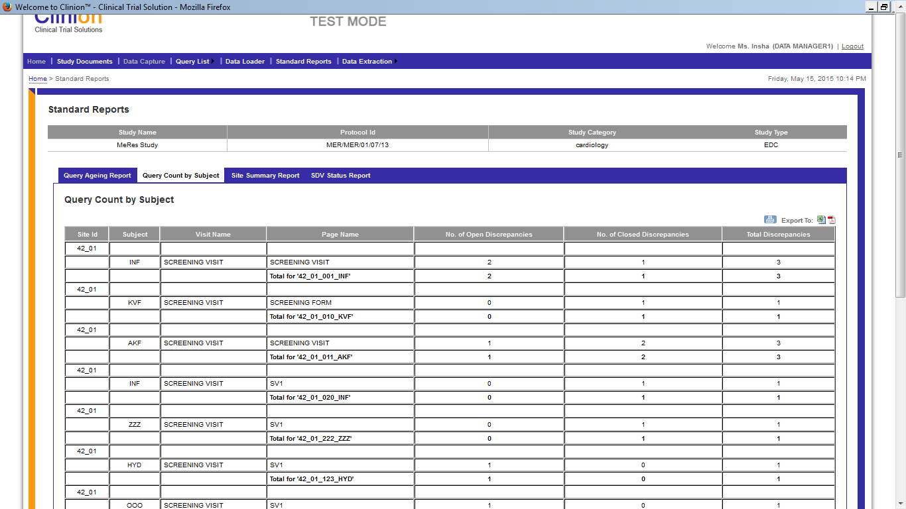

Figure.6.1: Standard Reports – Query Count By Subject

* **Site Summary Report** has the following details:

1. Site ID
2. No. of eCRF’s entered
3. No. of Queries Raised
4. No. of Open Queries
5. No. of Closed Queries

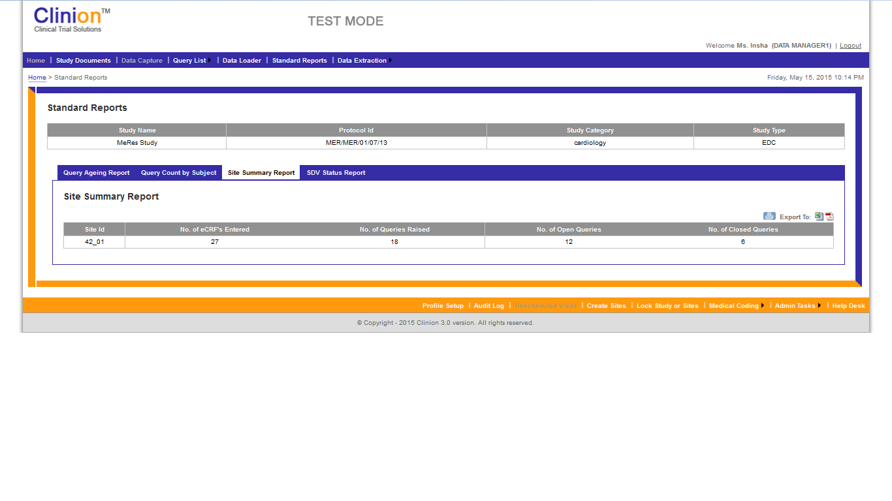

Figure 6.2: Standard Reports: Site Summary Report

* **SDV Status Report** page has filter options for Sites, Subjects, Page Status and SDV Status. The other details presented in the table are as follows:

1. Site ID
2. Subject
3. Visit Name
4. Page Name
5. Page Submitted
6. SDV Status

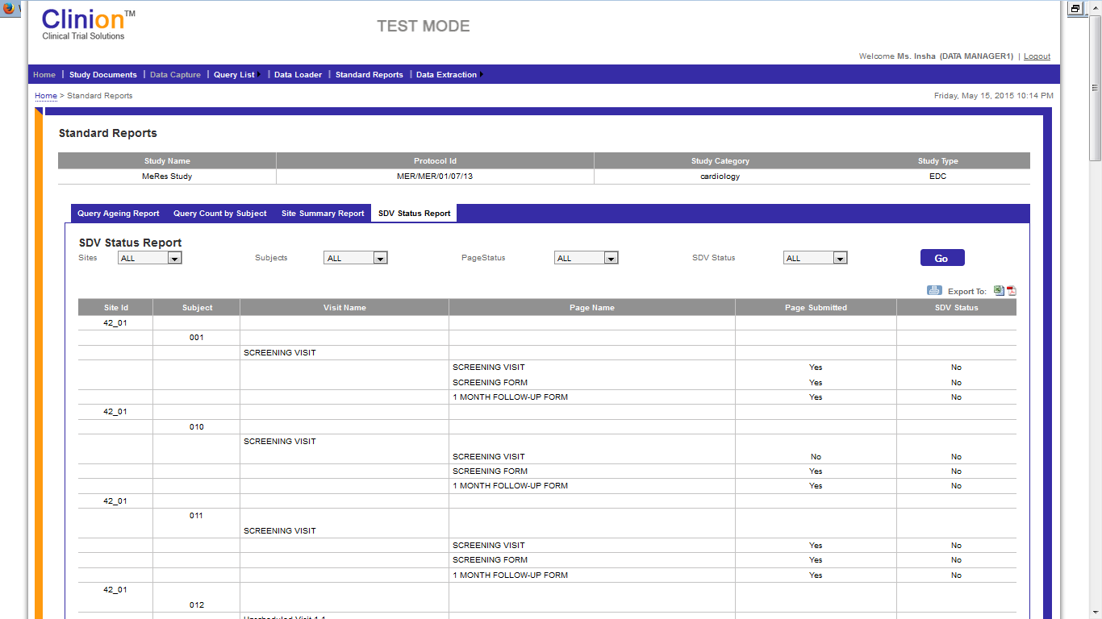

Figure 6.3: Standard Reports: SDV Status Report

## Data Extraction

* Data Manager can extract the complete data in the eCRFs.
* The application permits 7 types of Data Extractions that are available to the Data Manager.

1. CRF Data Extraction.

2. Notes Extraction

3. Attachments Extraction.

4. Medical Coding Extraction

5. CRF Book Extraction

6. Annotation CRF Book Extraction

7. QRS Extraction

CRF Data Extraction: Data Manager can extract CRFs:

1. Per Panel,
2. Per Dynamic Screen,
3. Unscheduled Visits page,
4. Page wise data extraction

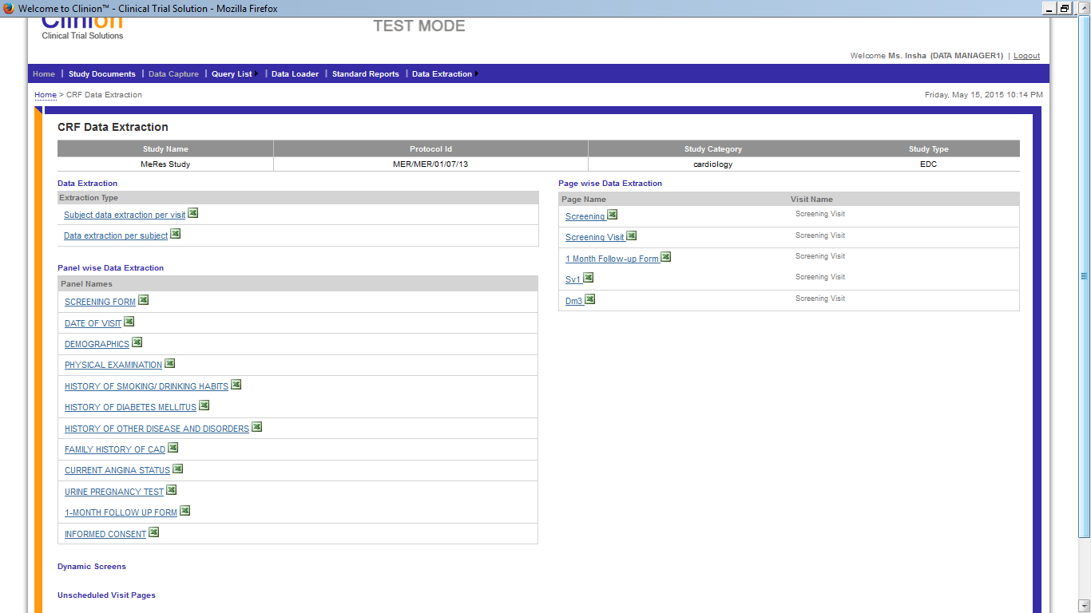

Figure.7.0: Data Extraction – CRF Data Extraction

* **Notes Extraction:** The Data Manager can extract the complete notes entered in the eCRFs, Page wise and Visit wise.

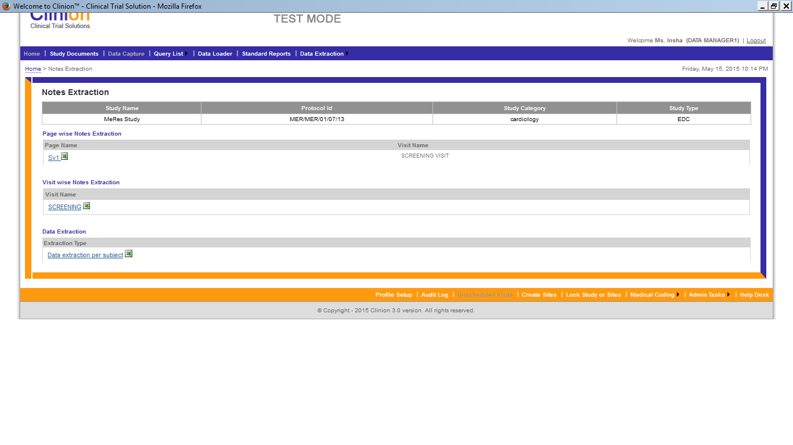

Figure 7.1: Data Extraction – Notes Extraction

* **Attachments Extraction:** Data Manager can extract all the Attachments in the CRFs of all the sites.
* **Medical Coding Extraction:** Data Manager can extract complete list of Medical coding done, both for Adverse Event terms and Concomitant Medication terms.

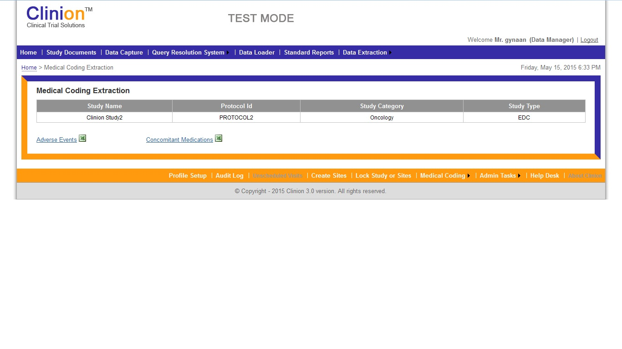

Figure 7.2: Data Extraction – Medical Coding Extraction

* **CRF Book Extraction:** Data Manager can extract the CRF Book for a particular subject and site by filtering and by clicking on Generate CRF.

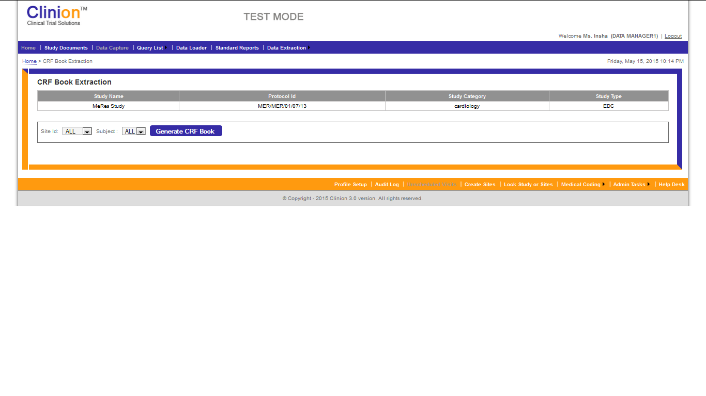

Figure 7.3: Data Extraction – CRF Book Extraction

* **Annotated CRF Book Extraction:** Data Manager can extract the annotated CRF Book for a particular subject and site by filtering and by clicking on Annotated CRF Book, button.

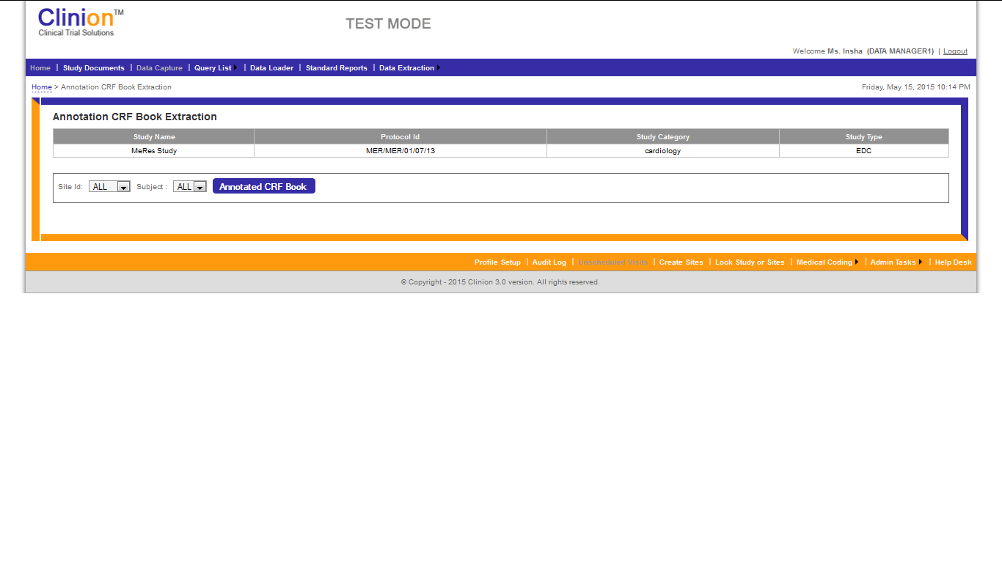

Figure 7.4: Data Extraction – Annotated CRF Book Extraction

* **QRS Extraction:** Data Manager can extract the Queries, per site, subject, visit or query status and those assigned to the data manager, by using the filter option. All this information can be exported to pdf and word files.

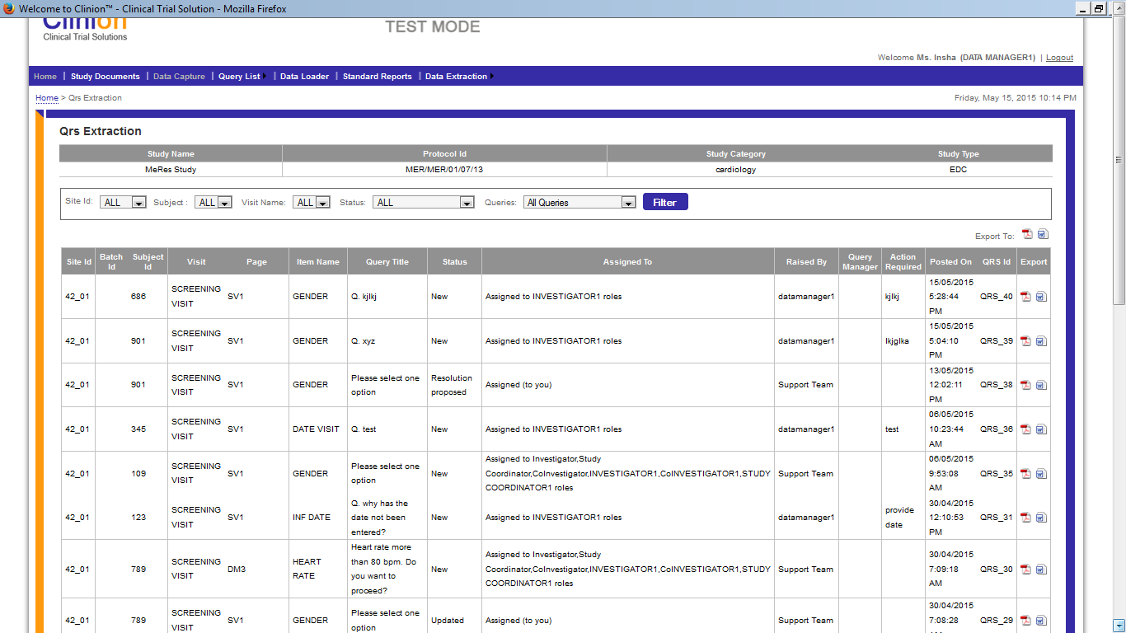

Figure 7.5: Data Extraction – QRS Extraction

## 4.6 Profile Setup

**Workflow:**

* The Data Manager clicks on “Profile Set-up” available in the footer to Create/Manage the users.
* After creating a user with all the required details, the password is sent to the email address provided.

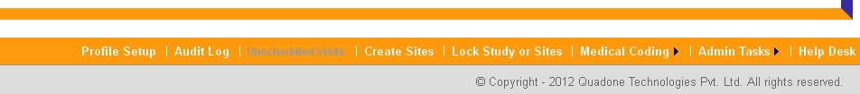

* The Data Manager can manage the user profiles by clicking on the edit link available beside the user.
* The Data Manager can Activate/ De-activate the user.
* The Data Manager can reset the password of the user. The password is auto generated and is sent to the user through mail.

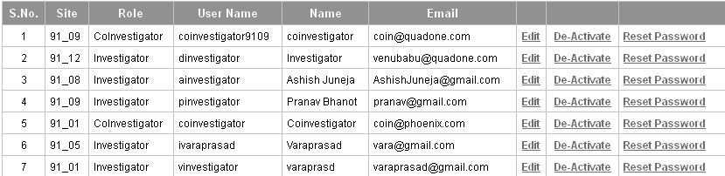

## 4.7 Audit Log

**Features:**

The Audit log captures the Data Item value changes and all the system activities.

* Data Manager has option to view Data Log and Activity Log.
* In the audit log, the changes against any Data Item are captured.
* All the information on the Audit log page can be exported to pdf file.

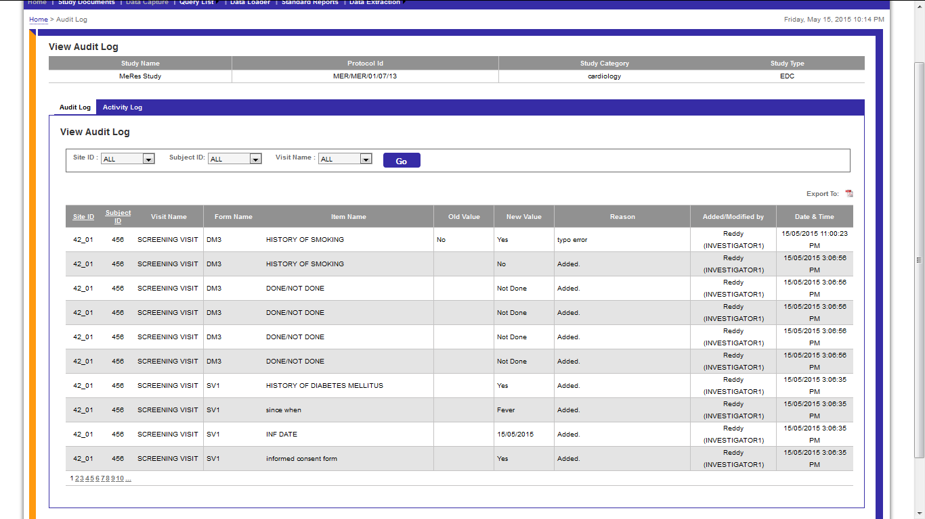

Figure 8.0: Audit Log – View Audit Log

**Workflow:**

* The Data Manager clicks Audit Log that displays the audit log section by default.
* The audit log section displays the Visit name, Form Name, Old value, New value, Reason for the change, Modified by (user name who modified the value), and Date and Time.
* Data Manager has an Option to filter audit log according to preferred Site, Subject or Visit.

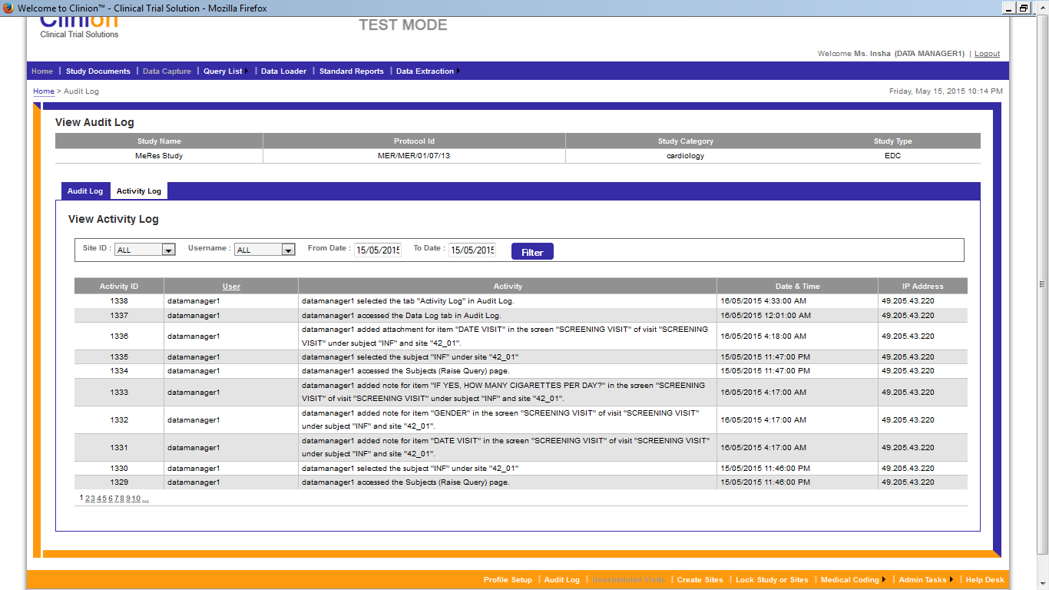

Figure 7.1: Audit Log – Activit Log

* When Data Manager clicks on Activity log, a list of all the activities done on the system is displayed along with the User, Activity, Date & Time, IP address of system

## 

## 4.8 Lock Study / Site

**Features:**

* The Data Manager can lock the Study or Sites at any point of time.
* The Data Manager can lock an individual site or can lock all the sites at a time.
* The Data Manager can unlock the sites or study once they are locked.

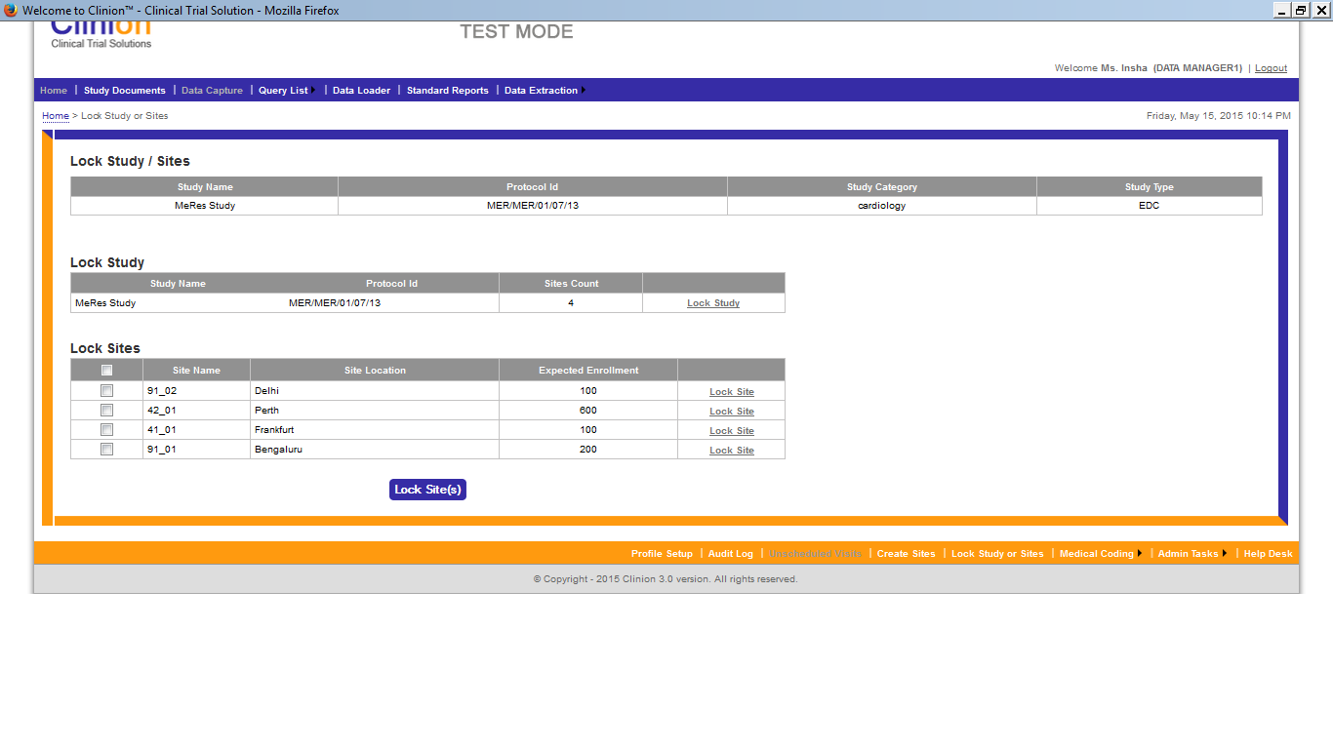

Figure 8.0: Lock Study/Sites

## 4.9 Create Sites

**Features:**

* The Data Manager creates Sites by providing the required details in the Create Sites page.
* All the created sites are displayed in the same page where there is an option to manage the sites’ information.

**Workflow:**

* By clicking on Create Sites menu in the footer, Data Manager can create a new site by providing the required fields:

1. Country (mandatory): Once the country is entered, country code, site code, site name and location are auto populated.
2. Address
3. Phone
4. Select Time Zone (mandatory): Data manager has the option to keep the study time zone applicable, by selecting the check box, ‘Keep Study Time Zone’, above Time Zone drop down box.
5. Expected Enrolment (mandatory).

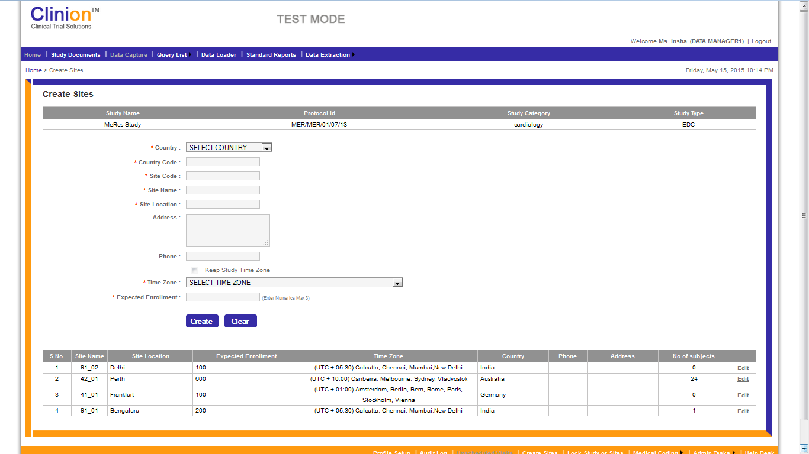

Figure 9.0: Create Sites

* Data Manager can also edit the existing Sites Information by clicking on ‘Edit’ option available in the Sites table next to each site.

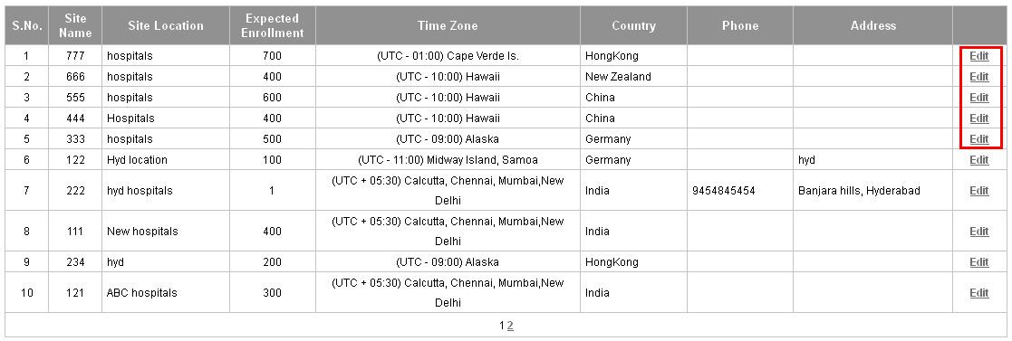

Figure 9.1: Create Sites (edit option)

## 4.10 Medical Coding

**Features:**

* Data Manager has option to run Medical Coding on Adverse event terms and Concomitant Medication terms with Auto and Interactive options.
* In Auto Coding, the system automatically matches the terms and displays the respective LLT, PT, HLT, HLGT and SOC.
* If the system has multiple matched terms in the dictionary, the respective terms are not auto coded are left for the user to do Interactive Coding on such terms.

**Work Flow:**

* Data Manager goes to Medical Coding and clicks Auto link where Data Manager can select AE log/ Con-med log.

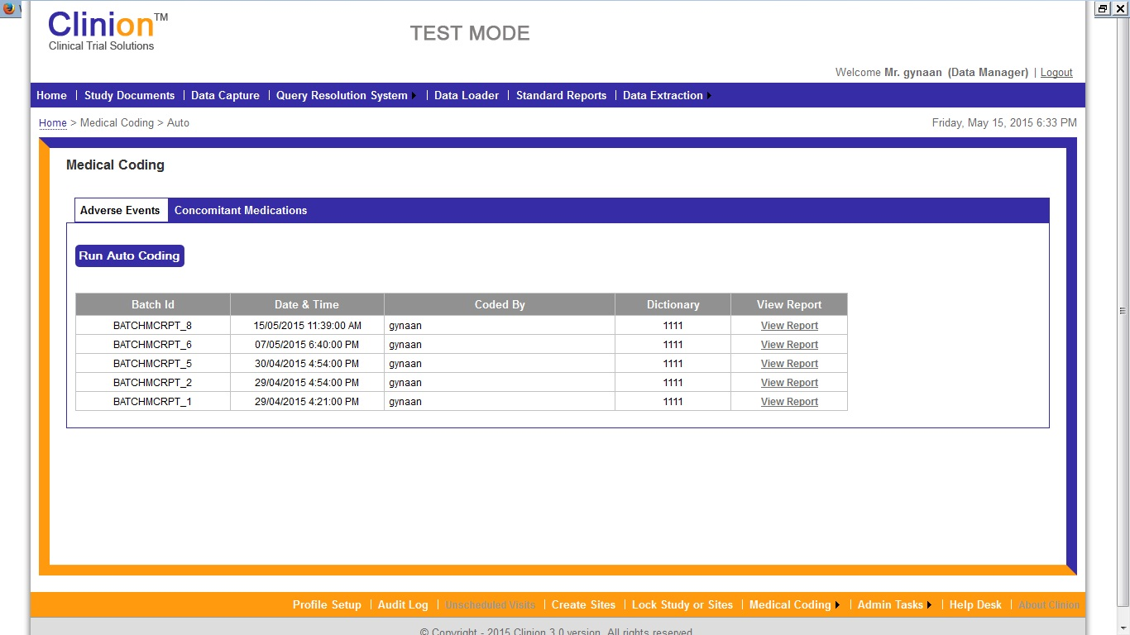

Figure 10.0: Medical Coding (Adverse Events)

* Data Manager has the option to Run Auto Coding. On the Medical coding page of both, AE and Concomitant medications, the data is presented with Batch ID, Date and Time, Coded By, Dictionary and View Report. The Reports for both AE and concomitant medications are links. Once the View Report linked is selected, the AE report page and the Concomitant Medications Report page, opens.

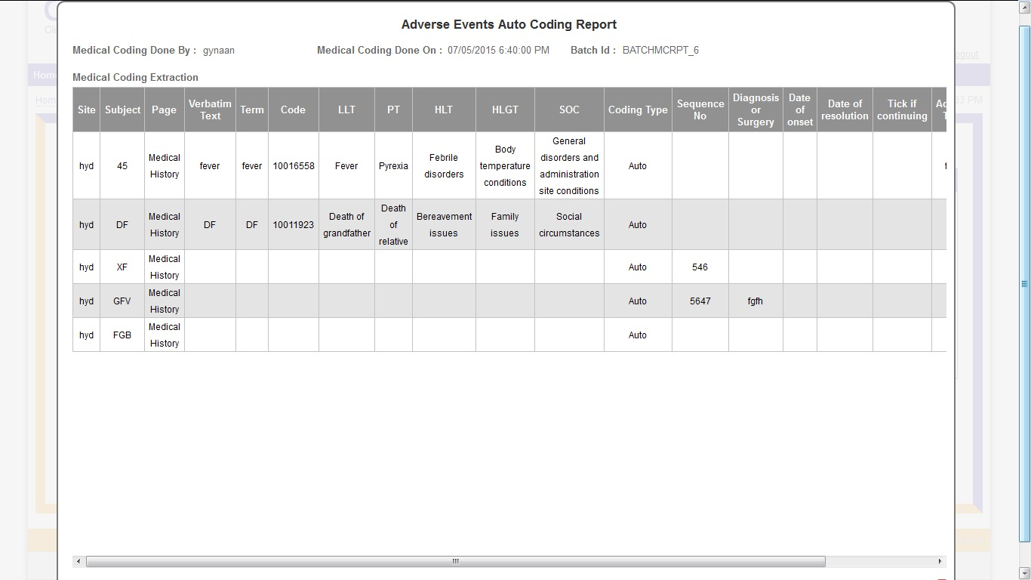

Figure 10.1: Medical Coding: Auto Coding (Adverse Event Report)

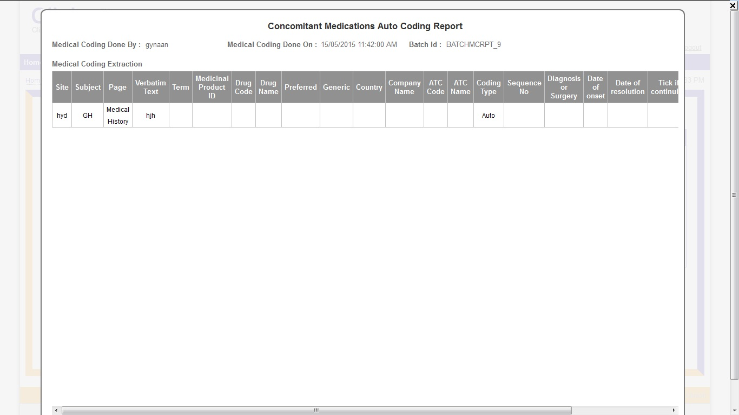

Figure 10.2: Medical Coding: Auto Coding (Concomitant Medications)

* The terms which are not auto coded can be done through the interactive way. Data Manager selects interactive from the footer menu of Medical Coding.
* Data Manager selects AE log or Con-med Log from the dropdown to perform Interactive coding.
* Data Manager clicks on the verbatim text to do Interactive Coding for the respective term.
* The selected ‘Verbatim Text’ is displayed in the Textbox. The Data Manager clicks on the required button to do Interactive coding.

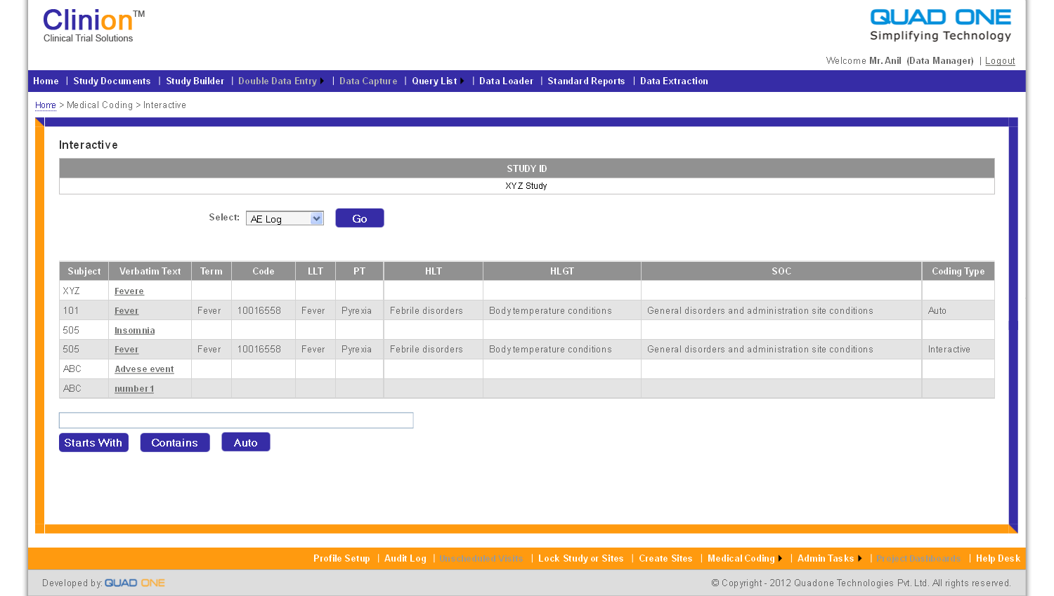

Figure 10.3: Medical Coding (Interactive)

* Data Manager can accept any of the terms from list of terms displayed.

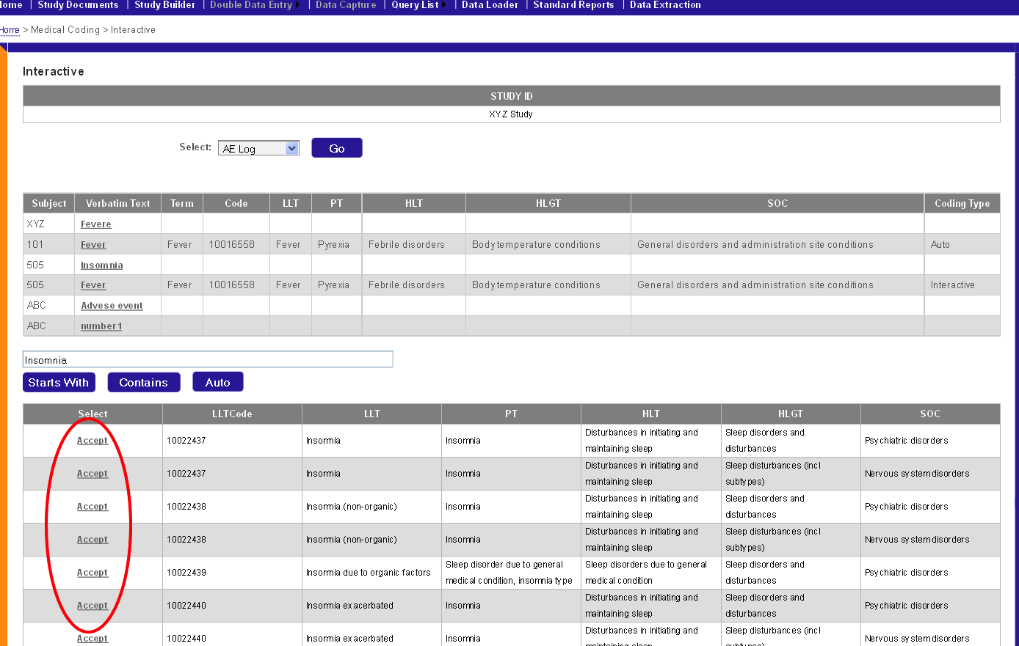

Figure 10.4: Medical Coding (Interactive)

* When the Data Manager clicks on ‘Accept’, the term is Interactive Coded and all the LLT, PT, HLT, HLGT and SOC terms are displayed along with the coding type.

## 4.11 Admin Tasks

**Features:**

* The Data Manager can change the password by clicking on the ‘Change Password’ in the Admin tasks menu in the footer.
* Data Manager can unlock the users Locked Users by clicking on the ‘Locked Users’ in the Admin tasks menu.

**Work Flow:**

* When Data Manager selects Change Password, Data Manager can change current password and configure new password.

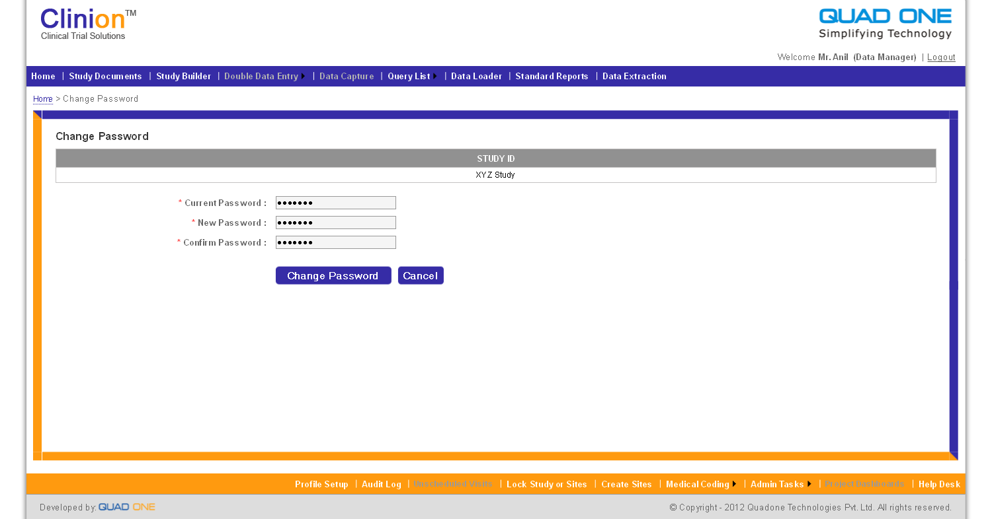

* Data Manager can unlock any Locked Users by clicking Locked users tab from Admin tasks.

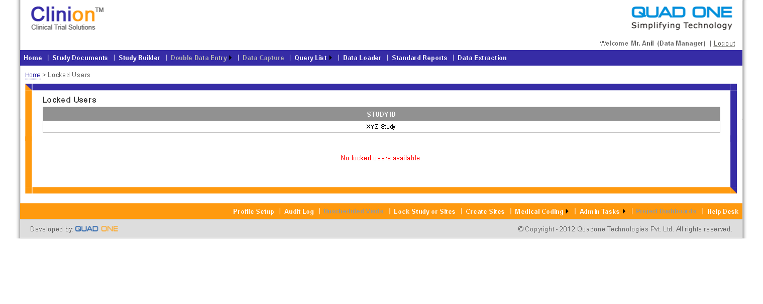

# 5.0 Help Desk

Level 1 : Insha F

Email : insha.fatima@quadone.com

Ph No : 040-23350221(ext-246)

Mobile : 9963027396

Level 2: Venu Babu

Email : [venubabu@quadone.com](mailto:venubabu@quadone.com)

Ph No : 040-23350221(ext-226)

Mobile : 9492437393

Level 3 : Anil Kumar

Email : [anil@quadone.com](mailto:anil@quadone.com)

Ph No : 040-23350221(ext-223)

Mobile : 9440739906